# 

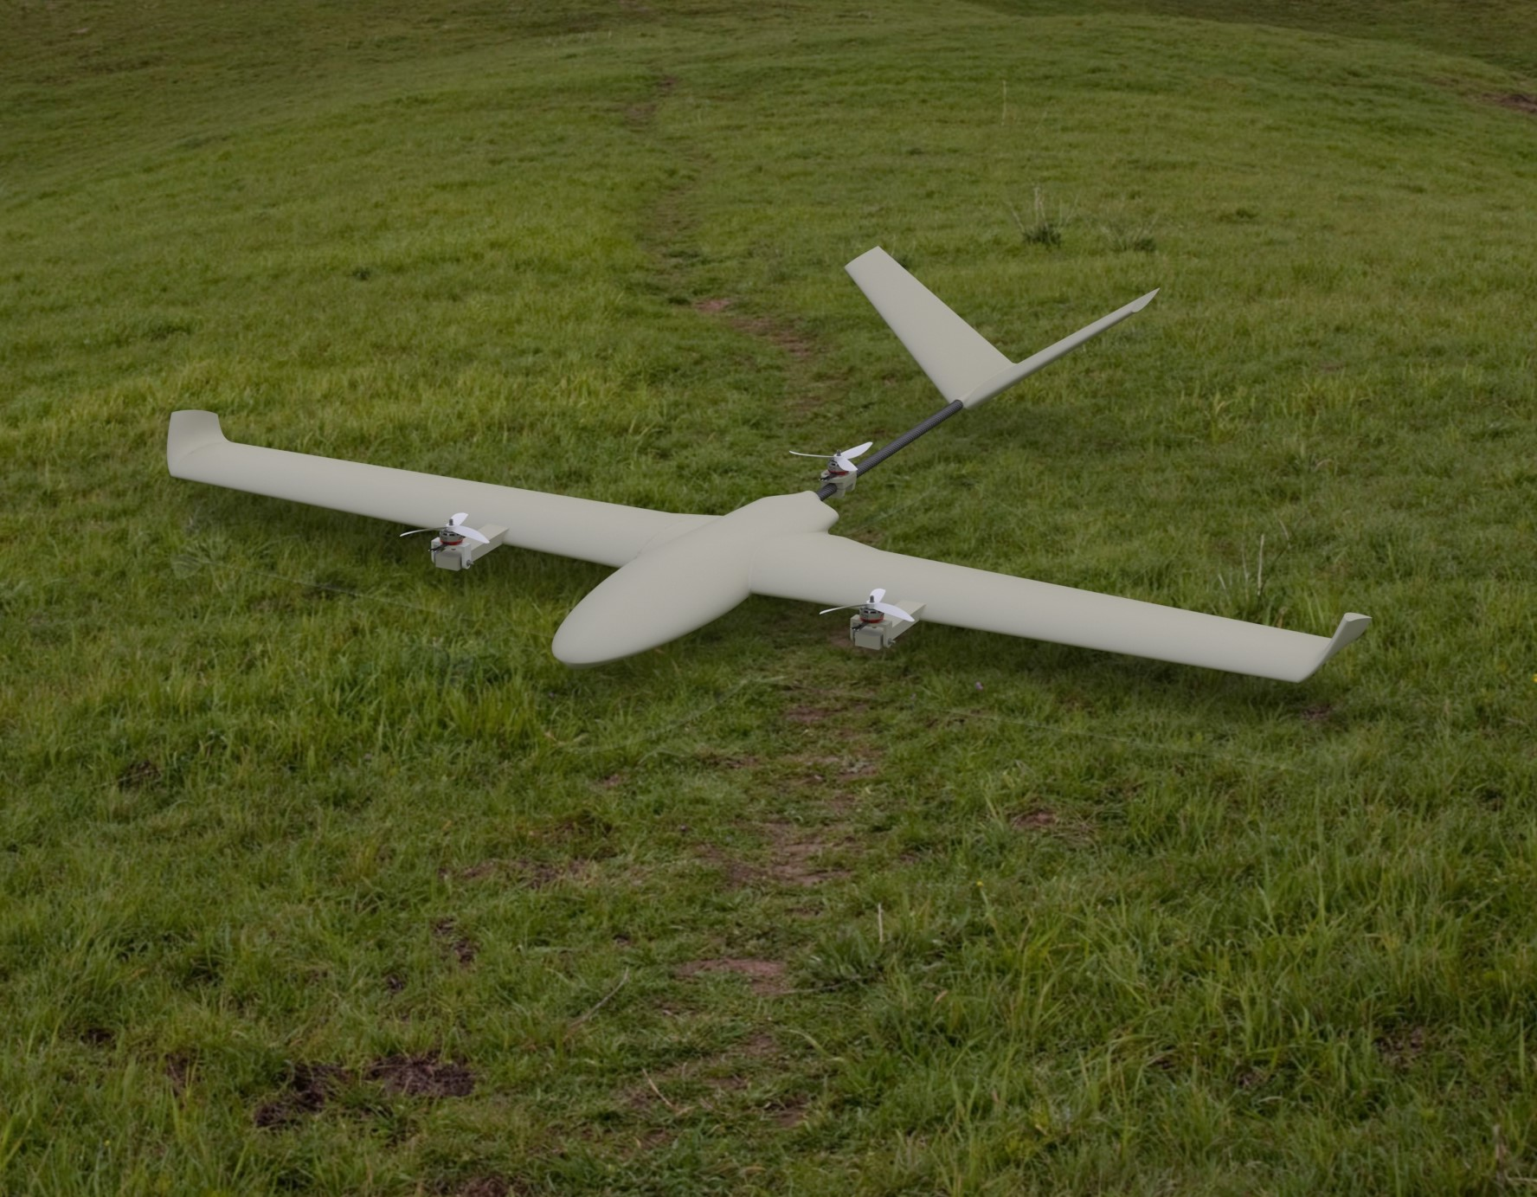

VTOL Aırcraft

ME 429 Mechanical and Thermal Design



Department of Mechanical Engineering

Boğaziçi University

Metin ÖZ

Harun ÜNER

# Executive Summary

The technological innovations have been significantly shaping the aviation. These innovations mainly affected unmanned aircraft vehicles in the last decades. This is largely thanks to developments in the electronics, as they get cheaper and more capable. Among them, multi-copters have a dominant share. However, the flight time and payload has some disadvantages in these UAVs. That is why, the hybrid models like Vertical Take Off Landing aircrafts have been getting attention. These air vehicles are capable of horizontal and vertical flight. These makes them highly advantageous. Among them, there are various configurations in terms of transition types and vertical flight types. This project intends to design a tiltrotor VTOL aircraft, because of its hover efficiency and compact structure.

In the design process, the purpose of project is explained. According to that, Product Design Specification is done. In this method, the important specifications like weight and control stability are listed, as they shaped the rest of the process. These specifications are explained according to their relevance to the project. After that, the specifications are hierarchically organized. This allows the proper allocation of the resources. This is done by using Binary Dominance Matrix. This method lists the parameter both horizontally and vertically. Then, they are compared one by one. At the end, specifications are listed with their importance weight. In the next step, possible design concepts are explained. These concepts have various rotor configurations and control mechanisms. The concepts are compared by the results of Binary Dominance Matrix. The concepts are graded for each specification. After the weighting, the concept of the project is selected.

The stated functional requirements give the wingspan, the take-off weight, and the cruise speed. According to that, airfoils are researched. The selection of airfoil is the most important part of the process, as they provide certain lift coefficient and drag coefficient for the selected Reynolds number. With these considerations, several airfoils are selected. After that, the wing is designed by using XFLR5 software. This software is specifically used for small-scale fixed wing vehicles. With XFLR5, multiple iterations are done, until sufficient lift is acquired. These iterations are done through the change of airfoil and the wing design. After that step, tail is designed in XFLR5. The tail is responsible for the orientation of the aircraft by generating pitching and yawing movements. The other function of the tail is making the plane statically stable. By using the tools provided by XFLR5, a V-tail is designed accordingly. Finally, a fuselage designed in the SolidWorks. In its design, physical integrity and the storage of electronics are the main considerations.

3D design of both wing and tail is carried out using SolidWorks. The internal structure of both wing and tail are needed to be done in SolidWorks. By using both SolidWorks and XFLR5, the bending moment and other factors are calculated for proper internal structure design. Simultaneously, dynamic stability analyses are carried out with XFLR5. In this analysis, several modes have been analysed. These analyses reflected on minor changes in V-tail position and orientation. Then, the motors and the battery and other electronics in the market research are selected accordingly. With the given size of propellers and other factors, the rotors are positioned in the plane. Since the front rotors are positioned outside of the wing, the necessary supporting units and tilting mechanisms are designed to support. Afterwards, the cost analysis is carried out. In the analysis, it is found that most of the cost comes from the flight controller and the battery. From the analysis, it is found that total cost is in the expected range.

As the planning of the project is not straightforward, some of the planning happened during the design process. However, it is mostly stuck to the initial planning, except minor changes. Project management shows the work distribution among the project members, as some of the work is done collectively. Finally, some of the problems faced in the design process are discussed.

# Table of Contents

**Executive Summary** 1

**1. Introduction** 5

**1.1. Fixed-winged Vertical Take-off Landing Air Vehicles** 7

**1.2. Project Objectives and Functional Requirements** 11

**2. Design Process** 13

**2.1. Design Criteria and Product Design Specifications** 13

**2.2. Overview of Possible Solutions** 16

**2.3. Detailed Design and Analysis** 20

**2.4. Cost Analysis** 32

**2.5. Project Management** 33

**3. Discussion** 35

**4. Conclusion** 37

**References** 39

**Appendices** 41

# List of Figures

***Figure 1.1*** *A Conventional Multi-Copter Drone. [3] 5*

***Figure 1.2*** *Comparison of Configuration Hover Efficiency. [4] 6*

***Figure 1.3*** *Euler Angles of the Air Vehicle with Body Orientation. [6] 6*

***Figure 1.4*** *F-35B Lightning Aircraft in Vertical Take-off Mode. [8] 7*

***Figure 1.5*** *A picture of V-22 Osprey. [9] 8*

***Figure 1.6*** *An Example of the Quad Plane Configuration. [10] 9*

***Figure 1.7*** *An Example of the Tail-Sitter Plane. [10] 9*

***Figure 1.8*** *An Example of Tiltrotor Drone. [10] 10*

***Figure 1.9*** *Pixhawk 6X Flight Controller from Holybro. [10] 10*

***Figure 1.10*** *Block Diagram of the Multicopter Control Algorithm from PX4. [11] 11*

***Figure 2.1*** *Product Design Specifications. 13*

***Figure 2.2*** *Wheel Chard of the Design Criteria. 15*

***Figure 2.3*** *An Example Configuration Diagram of the First Concept. [12] 16*

***Figure 2.4*** *An Example Configuration Diagram of the Second Concept. [13] 17*

***Figure 2.5*** *An Example Configuration Diagram of the Third Concept. [14] 18*

***Figure 2.6*** *Commonly Used Airfoils: (a) NACA-6412; (b) NACA-4412; (c) NACA-2412. 20*

***Figure 2.7*** *Polar Diagrams of Airfoils (Re=100.000). 21*

***Figure 2.8*** *Results of Force Analysis of the Final Wing Design. 22*

***Figure 2.9*** *Span-wise Free-Body Diagram of the Aircraft. 23*

***Figure 2.10*** *Constant Velocity (13.6 m/s) vs. AoA Analysis Results of the Aircraft with V-Tail. 24*

***Figure 2.11*** *The Numerical Deflection Analysis Results. 25*

***Figure 2.12*** *Longitudinal Modal Responses of the Vehicle: (Right-4) Phugoid Mode; (Left-4) Short-Period Mode. 26*

***Figure 2.13*** *Spiral Mode Modal Responses of the Vehicle. 27*

***Figure 2.14*** *Lateral Modal Responses of the Vehicle: (Right-4) Roll-Damping; (Left-4) Dutch-Roll Mode. 27*

***Figure 2.15*** *The Designation of Rotor Positions. 28*

***Figure 2.16*** *The Tilting Mechanism. 29*

***Figure 2.17*** *Wing Total Deformation Results of FEA for Horizontal Flight. 29*

***Figure 2.18*** *Wing Total Deformation Results of FEA for Vertical Flight. 30*

***Figure 2.19*** *Equivalent Stress on the Wing Results of FEA for Horizontal Flight. 30*

***Figure 2.20*** *Equivalent Stress on the Wing Results of FEA for Vertical Flight. 30*

***Figure 2.21*** *The Progress Tree of VTOL Design Process. 33*

***Figure 2.22*** *The Gantt Chard of the Designing of the VTOL aircraft for ME429. 34*

***Figure 2.23*** *The Gantt Chard of the Production of the VTOL aircraft for ME492. 34*

***Figure 3.1*** *An Example of XFLR5 User Interface. 35*

***Figure 3.2*** *The Element Quality Result of the Structural Analysis. 36*

***Figure 3.3*** *The Jacobian Ratio Result of the Structural Analysis. 36*

# List of Tables

***Table 2.1*** *Binary Dominance Matrix. 15*

***Table 2.2*** *The Decision Matrix and Concept Evaluation. 19*

***Table 2.3.*** *Geometric Parameters and Analysis Results of Design Iterations. 21*

***Table 2.4*** *Geometric Properties of the V-Tail Stabiliser. 23*

***Table 2.5*** *The Geometric Properties and Multiplication Constants of Wing Section with Different Chord Lengths. 24*

***Table 2.6*** *Expenditure Items and Prices for Mechanical Construction of the Vehicle. 32*

***Table 2.7*** *Expenditure Items and Prices of Electronic/Avionic Systems to be Purchased. 32*

# Introduction

In the aviation world, the technological innovations and new concepts have increased significantly in recent decades. Unmanned air vehicles are the focus of these developments. This can be largely attributed to their flexibility of use, new manufacturing techniques, the availability of electronic components and software. One of the main advantages of UAVs is their scalability. Conventionally, aircrafts have serious size limitation due to a need for pilot. Therefore, the manufacturing costs are quite expensive. On the other hand, UAVs have very large range of sizes. That allows creating significantly smaller air vehicles for various operations at a lower cost like the multi-copter in *Figure 1.1*. Additionally, new manufacturing techniques like 3-D printing and composite manufacturing allowed the sector to produce more complex parts without any serious cost for UAVs [1]. Furthermore, advancements in electronics and open-source software have accelerated the integration of complex control systems, sensors. These developments allowed the industry to create more sophisticated unmanned air vehicles with capabilities of precise navigation, real-time data transmission, and autonomous flight [2].

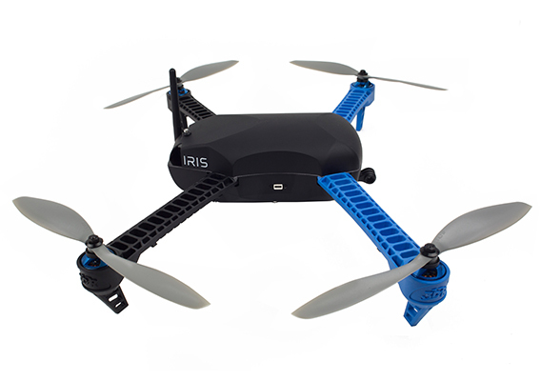

**Figure 1.1** A Conventional Multi-Copter Drone. [3]

Among unmanned air vehicles, multi-copter drones are the most common type of UAVs, without a doubt. The decrease in the cost of electronics and the developments in control systems are the main drivers behind its popularity. Additionally, its ease of use and manoeuvrability makes it superior to other UAVs. Especially, this manoeuvrability becomes crucial in places where the space is limited, and there is a lack of runway. The use of multi-copter drones ranges from agriculture, military to entertainment. Despite its advantages, hover efficiency of this type of UAVs are significantly lower than fixed-wing UAVs [4]. As the graph in the *Figure 1.2* shows, its hover efficiency is significantly lower than the fixed-wing UAVs. Because of that, the flight time of drones are around 15-30 minutes, while fixed-wing UAVs can be up to multiple hours [2].

**Figure 1.2** Comparison of Configuration Hover Efficiency. [4]

The take-off and landing of fixed-wing UAVs can be solved by using catapult systems or catching nets. The use of catapult systems is also used in military applications. However, accelerating air vehicles in a short period of time expose high stresses on the structure of UAVs. That limits the size and shape of UAVs and adds extra weight to endure high stresses. Furthermore, launching mechanisms adds additional transportation cost and may not be available in some applications. Therefore, the use of this system has its own limitation [5].

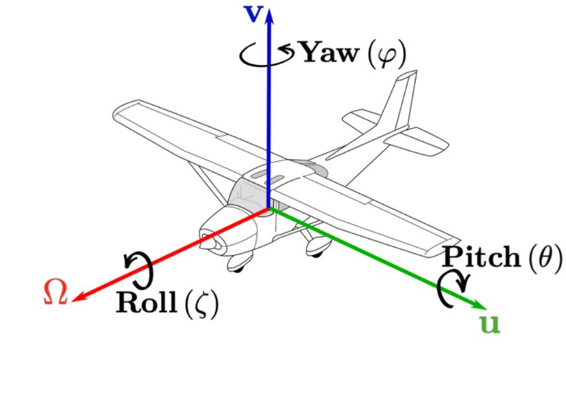

**Figure 1.3** Euler Angles of the Air Vehicle with Body Orientation. [6]

For better understanding of the project, it is also important to understand key notations like Euler angles. The state of an aircraft is described by Euler angles. Euler angles, which are yaw, pitch and roll, refer to the angles made by the vehicle with the coordinate axes and the reference coordinate axes. These are shown in *Figure 1.3*. Yaw refers to the rotation of the aircraft around its vertical axis, which determines the direction the nose of the vehicle points horizontally. Pitch, on the other hand, describes the rotation around the lateral axis, controlling the upward or downward tilt of the nose. Finally, roll corresponds to the rotation around the longitudinal axis, which tilts the aircraft's wings. The movements that change these angles are called pitching, rolling and yawing, respectively. [6]

## Fixed-winged Vertical Take-off Landing Air Vehicles

As stated in the previous parts, there is a significant trade-off between duration and a need for runway. While the hover efficiency of rotary wing aircraft can affect its flight time poorly, it also limits its range. Fixed winged conventional aircrafts can overcome this range issue with better hover efficiency and higher cruise speed, although it needs a serious infrastructure for take-off and landing. These concerns are the main motivations behind alternatives. That is why, vertical take-off landing air vehicles have caught great attention thanks to their hybrid nature. Vertical take-off landing air vehicles, VTOLs, has both forward flight and vertical landing and take-off capabilities. It can achieve this with several configurations. Technically, multi-copter drones are VTOLs, due to their both vertical and horizontal flight capabilities. Additionally, there are some UAVs with rotating wings which is also in the category of VTOLs. However, the term, VTOL, is generally used for fixed-winged VTOLs.

Fixed-wing VTOL aircrafts can perform high efficiency in their horizontal flight mode, like other conventional planes. They can also achieve vertical flight in limited spaces. Although every fixed-winged VTOLs have both forward and vertical flight capabilities, their configurations and how they managed the transition between vertical and horizontal flight can significantly differ.

Fixed-winged VTOLs are relatively new among other UAVs. But VTOLs are not only limited to UAVs. Fixed-winged VTOLs have been already in use in the US military. V-22 Osprey and F-35B are very successful example of VTOLs in military. The popularity of VTOLs mostly comes from their operational advantages in remote areas. Additionally, the popularity of V-22 Osprey comes from its superior flight range compared to rotorcrafts, as it is preferred over rotorcrafts for long range operations. Both V-22 Osprey and F-35B has marvellous engineering features and operates very differently.

F-35B Lightning II is a fifth-generation fighter jet equipped with a short take-off and vertical landing capabilities. Unlike other VTOLs, it operates its vertical flight by using his main jet engine with a use of fan system. Its rear nozzle design is one of the most engineering marvellous in aviation. It rotates the rear nozzle to redirect thrust for vertical flight. The hover flight mode configuration can be seen in *Figure 1.4.* In most cases, the vertical flight is not preferred during take-off and landing, because of high consumption of fuel. In war zones, the runway platforms can have serious damages, and the use of runway may not be possible. In these cases, most of fighter jets are not operable. This is the main hidden disadvantage of fighter jets. In these cases, the use of vertical take-off and landing have significant strategic importance. Compared to V-22 Osprey, its payload is significantly lower. The main difference between them is mechanism that used to produce thrust in vertical flight [7].

**Figure 1.4** F-35B Lightning Aircraft in Vertical Take-off Mode. [8]

V-22 Osprey is an American multi-use, tiltrotor military cargo aircraft. Its purpose initially was to combine the features of helicopters with turboprop aircrafts. Its initiation started with the failure of Operation Eagle Claw by US military. In this operation, the conditions showed that there was clearly a need for air vehicle that can perform vertical landing and has high range in the military. During its development, the tilting mechanisms which rotates the orientation of thrust were quite new and required complex mechanical and control approaches. There were also additional factors like additional weight due to these mechanisms. These issues take multiple years to handle. V-22 Osprey has two Rolls-Royce AE 1107 engines connected at the edge of the wings with tilting mechanisms responsible for both vertical and horizontal flight. The engines are shown in the *Figure 1.5*. V-22 Osprey are commonly used for the logistical support for aircraft carriers for US army where the ranges are generally above the helicopter’s range of operation and runway is insufficient for most cargo aircrafts [9].

**Figure 1.5** A picture of V-22 Osprey. [9]

As F-35B and V-22 Osprey shown, VTOLs can achieve vertical and forward flight in various configurations. Mainly, fixed-winged VTOL UAVs are classified into three categories. These are Quad-in-Plane VTOL drones, tail-sitter VTOL drones, tiltrotor VTOL drones.

Quad-in-Plane drones have a very similar structure with normal fixed-wing UAVs. This type has two type rotors which separately dedicated to vertical thrust and horizontal propulsion as shown in *Figure 1.6*. During the take-off and landing, the vertical rotors in the plane are activated and produces necessary. Between the vertical and horizontal flight, the transition occurs, which the vertical rotors deactivated, and the horizontal rotors are activated. This type of drones offers easier control in tough conditions. During horizontal flight, the vehicle can be assisted by vertical thrust engines for agile turns or recovery manoeuvres. The multi-layer control algorithm allows that. Because of their stable control, they are often used in geospatial mapping and agriculture.

However, it has several disadvantages. Unused rotors in horizontal flight creates additional undesired drag. Since some of these rotors are located in wings. That can also lower the lift through turbulence. Considering these situations, it would not be wrong to assume that efficiency will decrease. However, due to the fact that the motor used as the horizontal propulsion motor differ from other motors, they show a more efficient horizontal flight performance than tiltrotor VTOLs. The reason for that is the fact that the motors have different Kv values and can be combined with different propeller options to create combinations more optimised for horizontal flight. On the other hand, the unused rotors in the horizontal flight adds additional weight and slightly reduces the amount of payload that the vehicle can carry. [10]

**Figure 1.6** An Example of the Quad Plane Configuration. [10]

Tail-sitter has relatively minimalist design. It achieves the transition through the rotation of the whole frame. It does not have any tilting mechanism or any specialized rotors. Initially the UAV is positioned vertically to achieve vertical flight as shown in *Figure 1.7*. After the take-off, the drone transitions to horizontal flight with the control of ailerons. This transition model removes the need for tilting mechanisms or any additional rotors for different functions. This simplicity makes it costly advantageous and lightweight. However, the dynamic stability during transition phase requires more complex control algorithms, as the transition only occurs through the control of ailerons. In harsh weather conditions, this sophistication can make the flight impossible. Additionally, the vertical placement of the drone exposes high stresses on the frame. Making the drone structurally stable can consequently cause additional weight on the frame. These disadvantages limit the size of tail-sitter drones to small scale. These limitations limit the use of tail-sitter drones in tactical military operations and environmental monitoring. [10]



**Figure 1.7** An Example of the Tail-Sitter Plane. [10]

Tiltrotor VTOL rotors have very similar to fixed-wing planes. It has two types of rotors. The vertical rotors are generally placed near the tail. The tilting rotors are placed in the wings. The tiltrotor drone in *Figure 1.8* shows this configuration. These tilting rotors have tilting mechanisms that enables the drone dual flight mode. In take-off and landing, the tilting mechanism rotates the rotors in vertical orientation. In transition, it gradually orients itself in horizontal position to achieve horizontal thrust. Compared to quad-in-plane drones, it can perform similarly without any additional weight and thrust. Moreover, it can have high payload unlike tail-sitter drones. These advantageous are the main motivation for the motivation behind choosing tiltrotor VTOL as the project.

**Figure 1.8** An Example of Tiltrotor Drone. [10]

Another factor that plays an important role in the flight capability of the vehicles described above is the presence of a controller. The flight controller is an electronic system that controls actuators and maintains the stability of the vehicle. While it is the size of a computer in some large-scale vehicles, it is the size of microcontrollers such as Arduino in small UAV drones. Their processing capabilities also vary according to their scale. The flight computers of large vehicles can simultaneously operate radars, cabin systems, propulsion systems, fuel tanks, weapon rails and dozens of complex systems. On the other hand, drone flight controllers can only control simple tasks such as propulsion systems, control surfaces, vehicle positioning, ground station communication. Flight computers have multi-core processors operating at speeds of several GHz’s, while flight controllers have 2-4 thread microcontrollers operating at speeds of several hundred MHz’s.

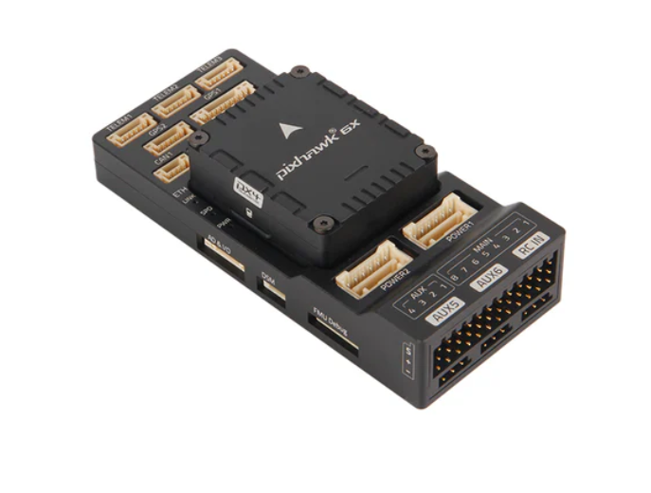

**Figure 1.9** Pixhawk 6X Flight Controller from Holybro. [10]

In *Figure 1.9* the Pixhawk-6X, the most advanced flight controller of the Holybro company, is shown. This flight controller with STM32-H753 microcontroller with up to 480MHz clock speed, 3 IMU sensors, 2 barometer sensors is a superior device in every sense. Thanks to UART, I2C CAN and even Ethernet connections, it can communicate and control many different peripherals.

As can be predicted, hardware without software is just an extra weight. Fortunately, there are 2 open source software supported by flight controllers; Ardupilot and PX4. Although these two software, both written in C++, fulfil the same function, they have slight differences. PX4 can work with applications such as Simulink and Gazebo. With Simulink, the flight code can be bypassed and allow the developer to run his own flight code. In the Gazebo environment, this flight code can be simulated and its performance can be evaluated. Ardupilot, on the other hand, targets the final user. The user can change many parameters without interfering with the flight code and can try developer updates. It has a clearer documentation and a larger community of users.

The flight code is the part of the code by which the propulsion and control surfaces are controlled to put the vehicle into the target state. It performs sensor fusion with the data it receives from IMU, barometer and GPS. For this, it uses instruments such as Kalman filter and Low Pass filter. States such as position, velocity, angle, angular velocity are calculated and fed into a cascading control algorithm to achieve the desired state. At each step, the independent PID algorithm is run and progresses in a stepwise manner from high level control to low level control. For example, the output of the position controller is converted into the input of the speed controller, the output of the speed controller is converted into the angle and so on. The final output is sent to the motor mixer to calculate the actuator states. A PWM signal is generated and transmitted to the actuators as an electrical signal. The control algorithm described is shown in the *Figure 1.10*.

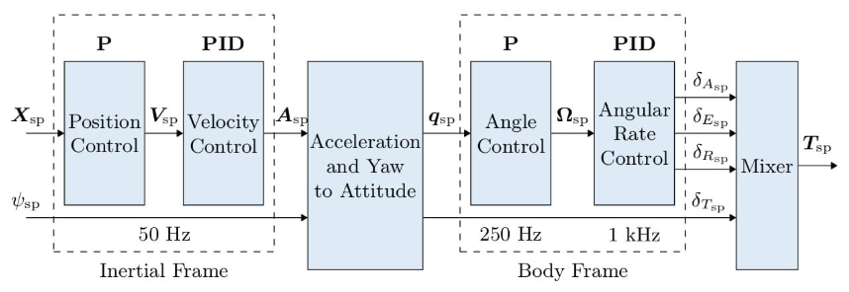

**Figure 1.10** Block Diagram of the Multicopter Control Algorithm from PX4. [11]

## Project Objectives and Functional Requirements

The main objective of this project is to design a functional fixed wing tiltrotor vertical take-off and landing (VTOL) aircraft. Today, fixed wing aircraft are outstanding for their efficiency and range in long distance flights. However, since they require long runways for take-off, their operational flexibility is limited. On the other hand, rotary wing aircraft, although they can be used in more compact areas thanks to their vertical take-off and landing capabilities, have disadvantages such as limited flight range and low speed. Combining the advantages of these two types of aircraft, the tiltrotor concept offers an innovative solution in the field of aviation.

Compared to other VTOLs, tiltrotor aircrafts perform better in both control stability and capability of payload. The use of same rotors horizontally and vertically with tilting mechanisms makes it more lightweight. The weight reduction should not be limited by the rotors themselves. Also, tilting mechanisms minimizes the additional structural elements that support each rotor. For the small-scale applications, using multiple rotors for each flight mode as in Quad-in-Plane type may not be seen as big disadvantages, due to their light weight. However, as the scale increased like V-22 Osprey; the weight of the rotors can have significant increase the overall weight [6].

Within the scope of the project, a detailed design of the tiltrotor VTOL aircraft will be carried out. In this project, various simulations and calculations will be performed to analyse the aerodynamic performance, flight dynamics and structural strength of the aircraft. The dynamic model of the aircraft will be used to investigate the behaviour of the vehicle in various flight scenarios. 3D design activities will also be developed to optimise the FDM printed structure of the vehicle, and to achieve design objectives and functional requirements.

In the analysis phase of the project, the wing and tail design will be optimised to fly at low speeds. The forces and torques encountered in different flight modes (vertical take-off, cruise, vertical landing, etc.) will be evaluated in detail. Dynamic analyses will be performed to determine the flight stability of the vehicle, while structural strength analyses will be carried out to evaluate the strength of the tilt mechanism and wings under external loads. Since the vehicle parts will be produced by FDM 3D printing method, which is an anisotropic production method, material properties are important for structural analysis. For this reason, an in-depth research on material properties will be required.

The scope the design is initially limited with specific requirements and limitations. The number of project members, limited time for the project, and the budget are the main considerations behind these requirements. The project is conducted by two members with a duration of one semester. Additionally, the budget for the project is only provided by the project members. These factors limited use of the electronics and the number of analyses to some extent. The specifications are decided with an extensive market research and the experiences of project members regarding the topic. In the research, similar aircrafts have been explored and this research has given certain idea about limitations and requirements for the projects. The Stallion-VTOL vehicle of the FLIGHTORY, which stands out with its similar features, was used to give an idea in the process.

The aircraft should follow the functional requirements given below.

**Functional Requirements:**

**-** Operating Conditions: VTOL is expected to operate in non-windy & clear weathers

**-** Semi-Autonomous Flight: The vehicle should be able follow a given flight path

**-** Tilt Rotor: The aircraft should have at least one tilt-rotor

**-** Manufacturing Constrain: Mostly 3D printable fuselage and wings

**-** Engine: Electrical power BLDC motors

**-** Power: 51.8-88.8Wh / 4s 16,8V 4500-6000mAh battery []

- Wing-Span: 1000-1500mm []

- Take-off Weight: 1000-2000gr []

- Stall Speed: 8-10m/s []

- Cruise Speed: 10-13m/s []

- Radio Control Range: Minimum of 300m

- Landing Gear: If it is essential for vertical take-off, 3-leg standoff

# Design Process

## Design Criteria and Product Design Specifications

In this part, design criteria are chosen according to the tiltrotor air vehicle. Product design specification is an extensive part that covers the essential prerequisites and necessary limitations and features. It is intended to lay out the important features in the tilt rotor air vehicles. For commercial products, Product Design Specification includes acceptance standards and disposal of the product regarding legislation and company policy. However, the project has no commercial interest. Therefore, acceptance standards and disposal regarding legislations are excluded from the selection of criteria. Product Design Specification which is shown in *Figure 2.1* can be classified in three categories as manufacturing requirements, performance requirements, and operation requirements.

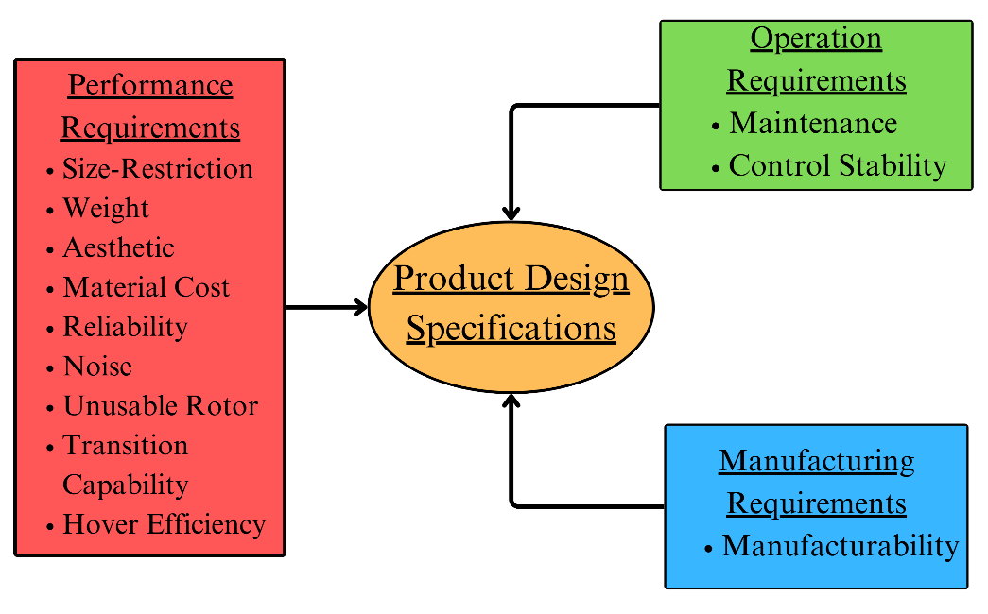

**Figure 2.1** Product Design Specifications.

***Performance Requirements:***

***Size-Restriction:*** In aviation, size can be very limiting factor for the motor and electronic options. Additionally, tiltrotor air vehicles have relatively complex structure due to their dual flight capabilities. That puts a minimum limit to its size due to the necessary electronics and battery. There is also restriction on upper limit due to the increasing complexity and other factors.

***Weight:*** Although the weight of the aircraft can depend on the size of the aircraft, the weight is more multidimensional parameter. It depends on the lift of the air vehicle and largely on battery and frame. Unlike automotive industry, the weight is one of the most important parameters in aviation. For the projects, the requirements like battery and wingspan put additional importance on this criterion.

***Aesthetic:*** Commercializing is not expected in the project. Consequently, the appeal of the consumer is out of concern. Despite that, the personal preferences in the project have given importance to this feature. Aesthetic can also be parallel with the functionality and practicality aspects of the product. These additional considerations made the aesthetic a part of the product design specification.

***Cost:*** The project does not have a sponsorship or any fiscal incentive from any institution. The project is financed by the project members. Additionally, the cost of tiltrotor aircraft has wide range of variation, due to the electronics, especially the battery. These factors significantly limit the project as a whole.

***Reliability:*** The aircraft is not intended to operate in risky operations. However, factors like the structural stability of the wings and the landing expose additional reliability issues for the operability. For the project, the aircraft should be operable at least multiple operations without being damaged.

***Noise:*** The propellers are the main cause of noise in tiltrotor air vehicles. But factors like shape, size, and angular speed can significantly affect the intensity of the noise. The noise can have very limiting effect on the crowded area for noise pollution. That is why, noise is chosen as an important criterion.

***Unusable Rotor:*** The efficient use of rotors has importance both on payload increase and the drag of the aircraft. In horizontal flight, the tiltrotor aircraft disables the vertical rotors for only horizontal thrust. This causes unusable rotors during that phase. Especially the placement of the vertical rotors around the airflow of wings can create significant turbulence which affects the aerodynamic efficiency poorly. In that sense, the unusable rotor is very crucial specification.

***Transition Capability:*** The main feature of VTOL air vehicles is their capabilities in both hover and horizontal flight. This occurs through transition. Transition can affect the performance of the plane in terms of power consumption, stability. In some configurations, the transition can be very poorly in windy conditions and the transition may not even occur. These considerations have made a vital specification for the project.

***Hover Efficiency:*** Similar to transition capability, hover efficiency is very crucial for the power consumption. Especially in tiltrotor VTOLs, during vertical flight mode, the motors consume a significant amount (about 25-40%) of battery energy.

***Manufacturing Requirements:***

***Manufacturability:*** Manufacturability stands for the construction of frame including fuselage, tail, and wing. It also includes assembly process of the frame with electronics. The manufacturing capabilities are limited by the equipment in the laboratories of Bogazici university. Electronics is expected to be by external manufacturers. The general role of manufacturing and other factors gives manufacturability its importance in our project.

***Operation Requirements:***

***Maintenance:* Maintenance** is a critical factor in ensuring the long-term functionality and safety of the tiltrotor air vehicle. Regular maintenance is not necessary for the project because of its limited use. After the operation, the plane should have a structure are easy to be inspected for any fracture in the frame. Additionally, the placement of the plane should be suitable to inspection.

***Control Stability:*** For tiltrotor air vehicles, control stability has a vital role. Hover flight requires accurate adjustments of the rotors in case of disturbances. Transition phase requires significant amount of stability. Also, air vehicles expose to various disturbances. For these conditions, control stability of the plane is crucial. Poor control stability can even cause to crash of the plane. All these considerations render control stability as a vital specification in the project.

**Table 2.1** Binary Dominance Matrix.



As Product Design Specification is done. These specifications must be hierarchically organized to enable successful selection in the concept models. These specifications are listed in Binary Dominance Matrix which can be seen in *Table 2.1*. The purpose of the binary dominance matrix is to organize the features according to their importance. The features are placed in both columns and rows. Then, the specifications are compared to each other. This gave a value for each specification. From that, the weight of the specifications is calculated. The weights of the criteria is shown as a wheel card in *Figure 2.2* for a visual expression. Since the weight of the noise aspect is 0, it is not shown in the figure. With that method, it is concluded that control stability and reliability are the most important features, while noise is the least important feature for the project. This stems from the major role of control stability and the relative negligibility of noise.



**Figure 2.2** Wheel Chard of the Design Criteria.

## Overview of Possible Solutions

When vertical take-off and landing aircraft are considered, it is observed that VTOL vehicles are differentiated from each other mainly by the number of rotors and the configurations of these rotors. Before starting the detailed design, the technical and practical benefits provided by different configurations were comprehensively evaluated in order to determine the most suitable configuration. The strengths and weaknesses of each alternative were taken into account to determine the configuration most compatible with the design objectives. During this evaluation process, each concept design was scored according to the criteria mentioned in Section 2.1 and the final concept design was determined using a decision matrix.

***Concept 1: Three-Rotor VTOL***

The first concept, the 3-rotor concept, is shown in *Figure 2.3*. In the three-rotor concept design, the front two rotors can rotate on the pitch axis, while the rear rotor generates thrust only during vertical take-off and landing. The front motors generate upward lift during vertical flight and change their tilt angles which are shown with α1 in *Figure 2.3* to provide forward thrust when the flight mode is switched to horizontal flight. The rear motor is used to increase total lift and to stabilise the aircraft during vertical flight. It is disabled during horizontal flight. [12]

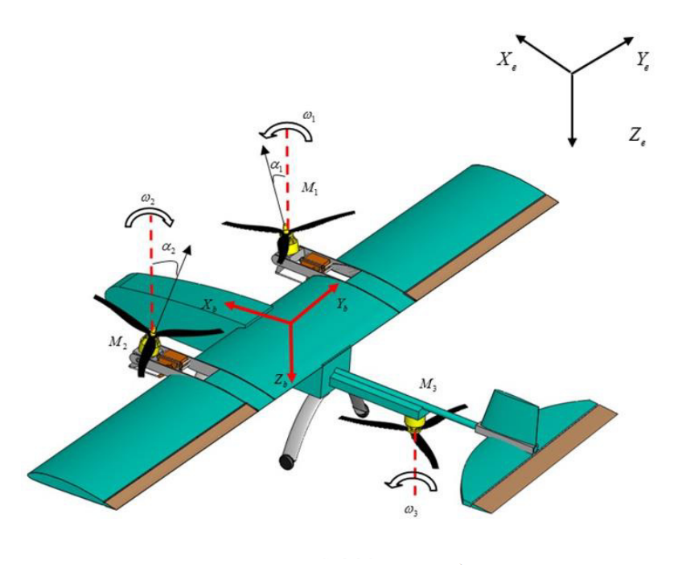

**Figure 2.3** An Example Configuration Diagram of the First Concept. [12]

The movement of the aircraft in the longitudinal axis is achieved by generating a non-zero horizontal force by the front-positioned motors. The downward tilt of the two front motors results a forward motion while speeding up rotors to keep the total vertical force constant.

The movement of the aircraft in the yaw axis is achieved by tilting the front motors in different directions. Meanwhile, the motors are speeding up in order to keep the vertical component of the thrust constant. While the coupled forces which are horizontal components of the thrust in different directions reset each other, it creates a nonzero moment in the yaw axis.

The movement of the aircraft in the roll axis is achieved by one of their front motors speeding up and the other slowing down. Thus, while the force remains constant on the vertical axis, a nonzero moment is generated on the roll axis.

During the transition, the front motors accelerate and tilt downwards. As the horizontal speed increased, generated lift by the wing is increase, and the rear motor start to slow down. When the vehicle reaches the cruise speed, the front motors are fully tilted and the rear motor is completely stopped. Hence, the horizontal flight mode begins. [10]

***Concept 2: Four-Rotor VTOL***

The second concept, the 4-rotor concept, is shown in *Figure 2.4*. In the four-rotor concept design, the front two rotors can rotate on the pitch axis, while the rear two rotors generate thrust only during vertical take-off and landing. The front motors generate upward lift during vertical flight and change their tilt angles which are shown with δ in *Figure 2.4* to provide forward thrust when the flight mode is switched to horizontal flight. The rear motors are used to increase total lift and to stabilise the aircraft during vertical flight. It is disabled during horizontal flight [13].

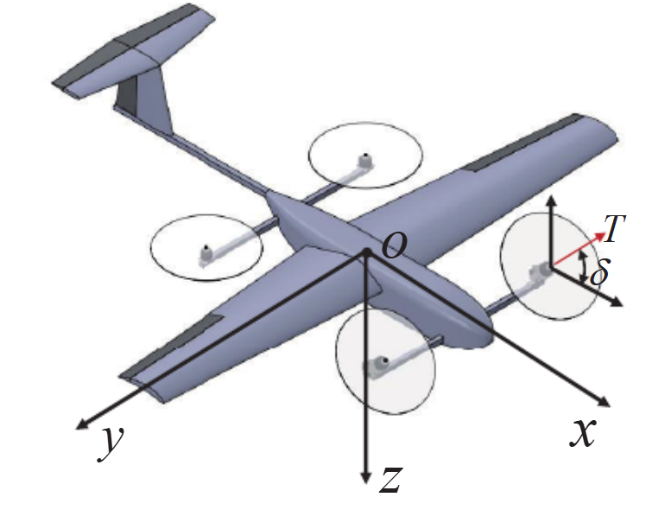

**Figure 2.4** An Example Configuration Diagram of the Second Concept. [13]

The movement of the aircraft in the longitudinal axis is achieved by generating a non-zero horizontal force by the front-positioned motors. The downward tilt of the two front motors results a forward motion while speeding up rotors to keep the total vertical force constant.

The movement of the aircraft in the yaw axis is achieved by the rotation at different speeds of pairs of motors which are rotated in the same direction and positioned diagonally. The left-front and right-rear motor rotate in clockwise direction, while the right-front and left-rear motor rotate in counter-clockwise direction. These pairs rotating at different angular speeds produce a nonzero torque while keeping the vertical force constant.

The movement of the aircraft in the roll axis is achieved by motors at the one side speeding up and the others slowing down. Thus, while force remains constant on the vertical axis, a nonzero moment is generated on the roll axis.

During the transition, the motors at the front will accelerate and tilt downwards. As the horizontal speed increases, the amount of lift generated by the wing is increased and the rear motors begin to slow down. The front motors are fully tilted and the rear motor is completely stopped when the vehicle reaches cruising speed. It is the start of the horizontal flight [10].

***Concept 3: Two-Rotor VTOL***

The last concept, the 2-rotor concept, is shown in *Figure 2.5***Figure 2.4**. In the two-rotor concept design, there are only two motors and is actively used in the both horizontal and vertical flight operation. The motors are positioned at the wing tips, and they can rotate in pitch axis. The challenging part of this design is to position the centre of gravity precisely on the line of intersection of the rotors. Otherwise, the couple forces create a moment in the pitch axis in vertical flight.

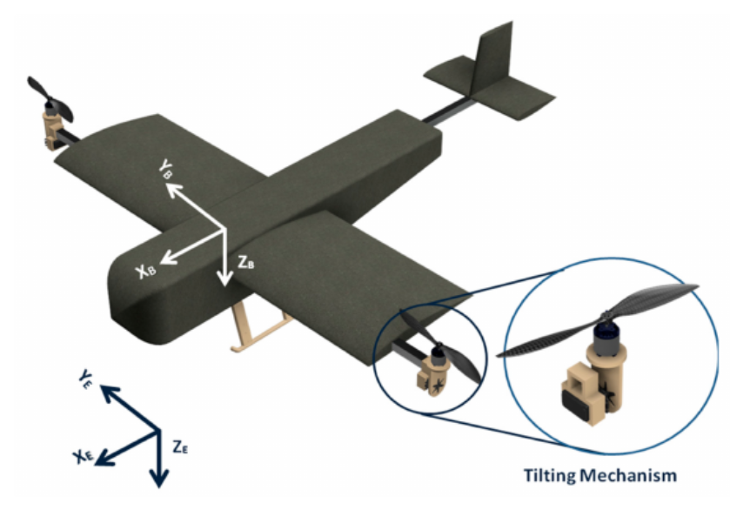

**Figure 2.5** An Example Configuration Diagram of the Third Concept. [14]

The movement of the vehicle in the longitudinal axis is achieved by tilting the motors forwards, as in other concepts. The downward tilt of the both motors results a forward motion while speeding up rotors to keep the total vertical force constant.

The movement of the vehicle on the yaw axis is achieved by tilting the motors in different directions. The thrust produced by each motor will increase until the total of the vertical component of the thrusts balances the weight of the vehicle.

The roll movement of the vehicle is achieved by increasing the thrust produced by the rotor on one side and decreasing the other. During the roll movement, the total thrust in the vertical direction does not change. However, the sum of the torques generated by the rotation of the motors will become a non-zero value. In order to eliminate this torque, the motors are slightly tilted in the opposite directions to generate counter-yaw torque.

During transition, the motors are slowly tilted forwards. However, unlike other concept vehicles, there is no motor to generate pitching moment in the positive direction. Therefore, if the vehicle stalls during the transition, it is very difficult to recover it. Although this concept is more efficient than the others, it has serious negatives in both design and control.

***Concept Evaluation***

Decision matrix is a systematic decision making tool used to select the most appropriate one among multiple options or alternatives. This method enables the scoring and comparison of alternatives according to specified criteria. the option with the highest score in total is preferred. Decision matrix is frequently used in engineering designs or in situations where a large number of variables are evaluated to create an objective and fact-based decision mechanism.

The decision matrix shown in *Table 2.1* was used to evaluate the mentioned concepts. Each concept was evaluated by the group members for the stated criterion. Each group member ranked the concepts for their success in that criterion. The leading concept was given 3 points, the next one 2 points and the least one 1 point. Then the scores given by each group member were summed up. The summation constitutes the individual score of each concept for that criterion. The total score of the concept was calculated by summing the weighted scores of each concept from the criteria. The scores for criterion and total scores of the concepts are shown in *Table 2.2*.

**Table 2.2** The Decision Matrix and Concept Evaluation.

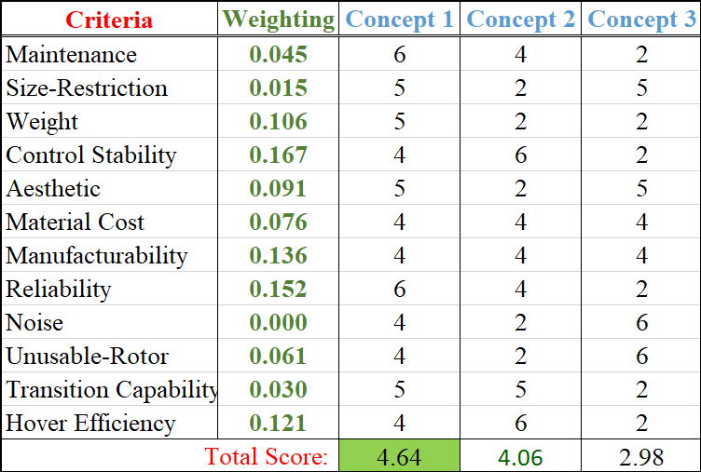

As can be seen in the *Table 2.2*, Concept-1 comes first with 4.64 points, followed by Concept-2 with 4.06 and Consept-3 with 2.98. As a result of it, the winning concept was a 3-rotor design, where the front two rotors can tilt and the rear rotor is active only during vertical take-off and landing. An example for the winner concept is shown in *Figure 2.3*. In following part of the design, further researches on this concept was conducted in more detail. Control stability, hover performance and reliability are particularly important factors in the selection of the concept. In addition, the transition capability and the reduced number of unusable-rotors are also among the reasons for the victory of the concept.

In the later stages of the design process, more detailed analyses were carried out on the winning concept. Within the scope of these analyses, the performance of the propulsion system in different flight modes was evaluated. In addition, factors such as structural strength and dynamic stability, which will ensure the long life and safe operation of the design, were also evaluated in detail. In this process, various optimisation and iteration studies were carried out to increase the suitability of the concept for different flight scenarios and to improve flight capability.

## Detailed Design and Analysis

VTOL which is an efficient combination of two types of flying vehicle, flies as a fixed wing on majority of its flight time. It was decided to design a fixed wing vehicle that can operate stably, and then construct the tri-copter frame on the fixed wing aircraft. The reason behind the decision is that fixed wing aircrafts have more inflexible design parameters such as wing length, location of the CoG (Centre of Gravity), AoA (Angle of Attack) of wing etc. On the other hand, it is relatively easy to adapt rotary-wing aircrafts to different frame designs, and they provide a wider range for the specification of design parameters.

The most important part of the fixed wing vehicles is their wings which produce lift to keep the aircraft on-air and a significant portion the drag. For this reason, the wing design is considered as the most prioritised stage in the design process of the aircraft. The aspect was taken into account in the progress of the project and it was aimed to select the airfoil that will meet to the design criteria of the vehicle. Therefore, airfoils commonly used in commercial RC (Radio-Controlled) aircrafts were surveyed, and it was found three profiles that stand out with their differing advantages in application. These are NACA-6412, NACA-4412 and NACA-2412; these airfoils are shown in the *Figure 2.6*.

National Advisor Committee for Aeronautics (NACA) is an organisation founded in the USA in 1915 and conducting aeronautics research. The aerodynamic surface shapes developed and tested by the organisation, whose name has changed to NASA, are called NACA airfoils. [15] Each digit in NACA 4-digit airfoils refers specific characteristic of the airfoil. First digit refers maximum camber as percentage of the chord length, second digit refers to location of maximum camber with respect to leading edge and last two digits refer maximum thickness of the wing profile as percentage of the chord length. [16]



**Figure 2.6** Commonly Used Airfoils: (a) NACA-6412; (b) NACA-4412; (c) NACA-2412.

The airfoiltools.com website was used to make comparative investigation of the selected airfoils. This web tool plots α (Angle of Attack) dependent variations of $C_{L}$ (Lift Coefficient), $C_{D}$ (Drag Coefficient), $C_{m}$ (Moment Coefficient) values of the airfoil for a certain Re (Reynolds number). As seen in the *Figure 2.7*, polar diagrams are generated for Re=100.000. NACA-6412 has a high $C_{L}$ value. NACA-2412 has a lower $C_{D}$ value at 0-5 degrees, which is the AoA of operation. NACA-4412 has intermediate values in all graphs, but it also can be an optimal option for different manufacturing techniques such as balsa spar-rib construction thanks to its semi-linear bottom line.



**Figure 2.7** Polar Diagrams of Airfoils (Re=100.000).

The next stage is to design a wing that can generate enough lift to compensate for the expected take-off weight at lengths and speeds within the design limitation. The wing must produce at least 15N lift force to balance minimum take-off weight at a maximum speed of 13m/s and its length must be in the range of 1300-1500mm. XFLR5, a numerical aircraft analysis and fixed wing design software, was used for this purpose.

XFLR5 is a software developed specifically for model aircraft, unmanned aerial vehicles (UAV) and small-scale fixed-wing vehicles. The program is capable of both 2D aerodynamic and 3D numerical analysis. In wing design, XFLR5 is useful with its three-dimensional analysis capability. Using the panel method, aerodynamic properties of the wing such as lift, induced drag and moment can be computed. 3D Panel Method is ideal for evaluating the performance of wings with different geometries. Furthermore, the user can determine the aerodynamic centres of the wing and stabilisers and examine the effect of in-flight moments on stability.

The process was carried out through iterations and the optimal wing geometry was tried to be obtained. The primary focus was on the lift force, while the total drag force and pitching moment were also considered. 3D Panel Analysis method was used and constant lift analysis condition was applied. 1.5 kg of point mass is located at quarter chord length from the leading edge. The algorithm calculates the minimum speed required for the wing to generate sufficient lift at different AoA values, and the software stores the operation points. Total of 6 iterations were performed. Some significant geometric parameters of the wing designs and their required minimum speed obtained from the analysis are shown in *Table 2.3.*

**Table 2.3.** Geometric Parameters and Analysis Results of Design Iterations.

|  |  |  |  |  |  |  |
| --- | --- | --- | --- | --- | --- | --- |
| Parameters | 1st  Iteration | 2nd  Iteration | 3rd  Iteration | 4th  Iteration | 5th  Iteration | 6th  Iteration |
| Wing Span *[m]* | 1.300 | 1.300 | 1.500 | 1.500 | 1.500 | 1.640 |
| Wing Area *[m2]* | 0.191 | 0.210 | 0.251 | 0.251 | 0.252 | 0.266 |
| Airfoil (NACA) | N-4412 | N-4412 | N-4412 | N-6412 | N-6412 | N-6412 |
| Root Chord *[m]* | 0.230 | 0.230 | 0.230 | 0.230 | 0.250 | 0.250 |
| M.A.C. *[m]* | 0.191 | 0.191 | 0.191 | 0.191 | 0.191 | 0.186 |
| Wing Load *[kg/m2]* | 7.843 | 7.143 | 5.970 | 5.970 | 5.980 | 5.726 |
| Tip Twist *[˚]* | 0 | 0 | 0 | 0 | -3.0 | -3.0 |
| Aspect Ratio | 8.837 | 8.048 | 8.995 | 8.955 | 8.970 | 10.10 |
| Tilt Angle *[˚]* | 2.0 | 2.0 | 2.0 | 2.0 | 3.0 | 3.0 |
| Cruse Speed *[m/s]* | 18.75 | 17.37 | 15.23 | 13.22 | 13.16 | 12.77 |
| Stall Speed *[m/s]* | 12.2 | 11.28 | 9.854 | 9.249 | 9.202 | 8.923 |

In the first iteration, the rough dimensions of the concept vehicle were taken as the initial values. Since the minimum velocity to produce sufficient lift was outside the design limits, it is decided to increase the wing area in the second and third iterations. At the fourth iteration, it was realised that a higher $C_{L}$ airfoil was needed. Therefore the profile changed to NACA-6412 which offers almost 20% higher $C_{L}$ at 2˚ AoA (See *Figure 2.7*). At the fifth iteration, the tilt angle of the wing is increased to 3˚ with negative tip twist angle of 3˚ and the root chord was increased to compensate for the resulting lift. This type of negative tip twist is called wing washout and provides many benefits. Especially at high angles of attack, flow separation starting from the wing tips is observed and it causes a dangerous situation, loss of aileron control [17]. The washout is useful technique to prevent it. Additionally, it reduces the rotational moment generated by the wing. Final iteration is completed with the addition of winglets. They are beneficial for reduces the wing tip vortices and cause little improvement of the lift force. Also, in all design sweep angle is applied to keep maximum thickness position of the airfoil as straight line along the wing. It is the line where we will position the spar tube that will provide the strength of the wing, and a straight maximum thickness line gives the flexibility in determination of the tube diameter.

Final geometry of the wing is given in *Appendix A*. For a more comprehensive performance evaluation, 3 different analyses are performed for final iteration. Those are Constant AoA vs. Velocity which computes generated forces, Constant Lift Force (15N) vs. AoA which computes required air speed and Constant Velocity (12.8 m/s) vs. AoA which computes generated forces. Drag and lift forces versus velocity and α is plotted and polar are shown in *Figure 2.8*.



**Figure 2.8** Results of Force Analysis of the Final Wing Design.

After the wing design process, the aircraft needed a tail. The tail is used to compensate the moments of the aircraft and responsible for generating pitching and yawing movements by affecting resulting moments of the aircraft. Another important concept for fixed-wing aircrafts is Tail Volume coefficient. It is a non-dimensional scale of tail effectiveness. It can be easily derived from span-wise Moment Equilibrium of the aircraft [18].



**Figure 2.9** Span-wise Free-Body Diagram of the Aircraft.

During calculations $C_{m}$ of the horizontal stabiliser is neglected, and it is assumed that y-axes of the CoG is such that the moments produced by drag forces of the wing and the horizontal stabiliser cancel each other. Also, x-axes position of the CoG is located on quarter-chord length behind from the leading edge. FBD of the aircraft is shown on the *Figure 2.9*.

${F_{Wing}=q∙C_{L, wing}∙A_{wing} and F}_{elev}=q∙C_{L,elev}∙A_{wing}$

Eq. 2.1

Lift forces calculated by *Eq. 2.1* where *q* is dynamic pressure and *A* is area of a member. The total moment about the CoG is:

$$\sum{M}=\frac{1}{4}∙L_{chord}∙F_{wing}-L∙F_{elev}=0$$

Eq. 2.2

The moment caused by the lift at quarter-chord of the wing is also calculated by this:

$$M_{wing}=q∙C_{M}∙M.A.C∙A_{wing}=\frac{1}{4}∙L_{chord}∙F_{wing}$$

Eq. 2.3

By implementing *Eq. 2.1* and *Eq. 2.3* to total moment equation (*Eq. 2.2*) it gives:

$$C_{m,wing}=\frac{L∙A_{elev}}{M.A.C∙A_{wing}}∙C_{L,elev}=TV∙C_{L,elev}$$

Eq. 2.4

The Tail volume constant is calculated by the *Eq. 2.4* where *M.A.C.* is mean aerodynamic chord length and *L* is lever length of the horizontal stabiliser. For sailplanes, TV for horizontal stabiliser is between 0.5 and 0.7, and during design process of the tail, it was worked in the interval [18]. A horizontal stabiliser was designed with aspect ratio of 3.5, and it was converted a V-Type tail design without changing its projected area. Some geometric properties of the V-Tail stabiliser can be seen in *Table 2.4*. Technical drawings and detailed dimensions of the tail is provided in *Appendix B*.

**Table 2.4** Geometric Properties of the V-Tail Stabiliser.

|  |  |
| --- | --- |
| P. Stabiliser Span *[m]* | 0.500 |
| P. Stabiliser Area *[m2]* | 0.06 |
| Airfoil (NACA) | N-0012 |
| Root Chord *[m]* | 0.180 |
| Tip Chord *[m]* | 0.100 |
| M.A.C. *[m]* | 0.152 |
| Tilt Angle *[˚]* | -3.0 |
| Tail Volume | 0.61 |
| Dihedral Angle *[˚]* | 35.0 |
| Lever Arm, L *[m]* | 0.650 |

Another important concept for the tail design is consideration of the static stability. XFLR5 is able to compute the total moment coefficient of the vehicle. There are two graphs in XFLR5 that should be examined to verify static stability. $C_{M}$ vs. α graph must have negative slope, it means that the increasing α creates negative pitching moment that will bring the vehicle back to its equilibrium. At equilibrium α, the wings could generate sufficient lift to keep the vehicle on air. As seen in *Figure 2.10*, the aircraft can fulfil both condition at *13.6* *m/s* with generated 16*N* lift . Although the velocity is a bit out of the design margin, it is still acceptable.



**Figure 2.10** Constant Velocity (13.6 m/s) vs. AoA Analysis Results of the Aircraft with V-Tail.

After that stage, the 3D design and dynamic stability analysis were carried out simultaneously. The main reason behind this was the fact that the moment of inertia of the vehicle was required for dynamic stability analysis. SolidWorks had been used as the 3D design software. The vehicle was designed as an outer shell and an internal structure to support the shell. Since additive manufacturing was preferred for production, designing complex internal structure will not cause any major production problem. It was aimed to overcome the disadvantage of low-strength property of the FDM printing technique by utilising pre-produced composite materials in sections requiring strength.

The dimensions of the spar tube to be selected to reduce the deflection and increase the overall strength of the wing were determined by numerical analysis. In order to simplify calculation, internal structure of the wing was not taken into account, and only the wing shell and composite tube were included in the analysis. The second moment of area of the wing profile was computed by the SolidWorks. I Shell for a profile with 250*mm* of chord length and 0.8*mm* of thickness equals to 55082 *mm4*. It was observed that I Shell is proportional to the cube of the chord length with a multiplication constant of 3.53ₓ10-6. The distance between neutral axis of tubular section and neutral axis of the total section is observed as proportional to the chord length with a multiplication constant of 1.22ₓ10-2. Similarities are checked for 5 different section of wing profile and multiplication constants are given in *Table 2.5.*

**Table 2.5** The Geometric Properties and Multiplication Constants of Wing Section with Different Chord Lengths.

|  |  |  |  |  |
| --- | --- | --- | --- | --- |
| Chord Length *[m]* | I Shell *[m4]* | D trans *[m]* | CI *[m]* | CD,T |
| 0.250 | 55082ₓ10-12 | 3.06ₓ10-3 | 3.52ₓ10-6 | 1.22ₓ10-2 |
| 0.220 | 37568ₓ10-12 | 2.68ₓ10-3 | 3.52ₓ10-6 | 1.22ₓ10-2 |
| 0.200 | 28242ₓ10-12 | 2.44ₓ10-3 | 3.53ₓ10-6 | 1.22ₓ10-2 |
| 0.190 | 24213ₓ10-12 | 2.30ₓ10-3 | 3.53ₓ10-6 | 1.21ₓ10-2 |
| 0.180 | 20645ₓ10-12 | 2.18ₓ10-3 | 3.54ₓ10-6 | 1.21ₓ10-2 |

XFLR5 is able to compute bending moment caused by the lift and drag, the results that causes maximum bending moment were exported to MATLAB. Since positions of the motors haven’t yet been decided, the vertical point force generated by the propellers in vertical flight was assumed to be applied at the farthest point of the wing from the centre. The total Flexural Rigidity for a composite beam is derived below.

$I_{t}=I_{1}+nI_{2},$ $n=\frac{E_{2}}{E_{1}}$ [19]

Eq. 2.5

Where $I_{1}$ and $I_{2}$ are second moment of area about neutral axis of composite beams, and $I_{t}$ is the equivalent second moment of area for entire beam made of a material with elastic modulus of $E_{1}$. The Flexural Rigidity, D is calculated as;

$$D=E_{1}I_{t}=E_{1}I_{1}+E_{2}I_{2}$$

Eq. 2.6

And so on, the deflection of the wing is computed by using Eq. 2.7 and *cumtrapz* function of the MATLAB by applying boundary conditions where the deflection and its slope are equal to zero at the centre. MATLAB Code to compute the deflection is given in *Appendix C.*

$\frac{d^{2}v}{dx^{2}}= \frac{M}{D}$ [20]

Eq. 2.7

The maximum deflection is expected not to exceed 10% of the wing length, which is 80*mm*. Accordingly, a 500*mm* long CFRP tube with an inner diameter of 10*mm* and an outer diameter of 12*mm* was used as the spar tube. Since the CFRP tube is sold in 1 metre pieces, not exceeding 0.5 metres for each wing will reduce the cost. As seen in the *Figure 2.11*, the maximum deflection which located at wing tips is not exceed 25*mm* in horizontal flight. Although a higher deflection is emerged during vertical flight, the results are still within an acceptable level.



**Figure 2.11** The Numerical Deflection Analysis Results.

The rough design was finalised taking into account the mentioned concepts. Moment of Inertias of the plane were exported from SolidWorks, and the battery, motors and other significant masses added to XFLR5 as point masses. Thus, the inputs required for the stability analysis were roughly fed into the programme. During the analysis, the damping ratios and frequencies of the natural aerodynamic modes are computed as eigenvectors and eigenvalues by XFLR5. The real parts of these eigenvalues are related to the damping coefficient and their imaginary parts correspond the frequencies. The resulting eight modes can be divided into, four longitudinal and four lateral modes, some of which are symmetric.

The longitudinal modes are two symmetric Phugoid Modes and two symmetric Short-Period Modes. The phugoid is a long period oscillation of change in altitude, that is caused by the exchange of kinetic and potential energy and it is usually lightly damped. For our plane the damping ratio, ζ of this mode is computed to be 0.033 and the damped natural frequency is 0.896 *Hz*. Its duration could be several minutes for a stable aircraft and the settling time is nearly 1.5*min* for the aircraft [21].Modal response is shown in right 4-graphs of *Figure 2.12*. The other longitudinal mode is the Short-Period mode. This mode is related to pitch rate and vertical displacement. It is usually high frequency and damped well. For the plane, the damping ratio, ζ of this mode is computed to be 0.553 and the damped natural frequency is 11.57 *Hz*. Its settling time is expected to be less than a second for a stable aircraft, it takes 0.6*s* stabilise for the aircraft [21]. Modal response is shown in left 4-graphs of *Figure 2.12*.



**Figure 2.12** Longitudinal Modal Responses of the Vehicle: (Right-4) Phugoid Mode; (Left-4) Short-Period Mode.

The lateral modes are Spiral Mode, one Roll-Damping Mode and two symmetric Dutch-Roll Modes. The Spiral Mode is primarily a change in heading and it is a non-oscillatory and slow mode and it is usually unstable. This mode is also unstable for the plane as can be seen from the modal response in *Figure 2.13*. Although it is unstable in Spiral mode, it can be easily corrected by the pilot since it is very slow. For the plane, the doubling time is computed to be 4.23*s* and the task of stabilizing it was assigned to the flight controller. Flight controllers with flight control software such as PX4 or Ardupilot, can easily handle such stabilization operations. It also improves the controllability of the vehicle, offers easier flight modes for the pilot and can operate the vehicle in autonomous flight modes [22].



**Figure 2.13** Spiral Mode Modal Responses of the Vehicle.

Another lateral mode is Roll-Damping which is related to a change in roll. This mode is non-oscillatory and usually fast. For our plane the halving time is computed to be 0.055*s*. The modal response of Roll-Damping mode is shown in right 4-graphs of the *Figure 2.14*. Lastly there is the Dutch-Roll mode which is a combination of roll and yaw change with a 90˚ phase difference. Dutch-Roll mode is usually lightly damped. For the plane, the damping ratio, ζ of Dutch-Roll mode is computed to be 0.165 and the damped natural frequency is 4.22 Hz. Modal response is shown in left 4-graphs of the *Figure 2.14*



**Figure 2.14** Lateral Modal Responses of the Vehicle: (Right-4) Roll-Damping; (Left-4) Dutch-Roll Mode.

One of the important parameters for a reliable vertical flight is the thrust-to-weight ratio. It is calculated as the maximum thrust obtained from the propellers multiplied by the number of rotors divided by the weight of the vehicle. While thrust-to-weight ratio is accepted in the range of 2-4 for quadcopters, it has been found that the range of 1.5-3 is recommended for VTOL vehicles that perform vertical flight for a short period of their flight. Considering a 3-rotor VTOL with a maximum take-off weight of 2 kg, the motors are expected to generate 1 to 2 kg-force static thrust. After the market research, Emax RS2205S-2300Kv model BLDC motors were selected. They are able to produce 1281 gr-force thrust with 3 blade 5045 propellers and they consume maximum of 33A current with nominal voltage of 16V. With this configuration, the thrust-to weight ratio is calculated as minimum of 1.92. Another market research was also conducted out for servo actuators to be used in the tilt mechanism. It was decided that Emax ES09MD Dual–Bearing servo actuators are suitable for the system. They have 2.6 kg-force.cm stall torque with angular speed of 6.55 rad/s at operating voltage of 6V. Thanks to dual-bearing design of output shaft, they can withstand not only twisting but also bending moments.

As the plane has three rotors, two at the front and one at the back; their positions must be designated. In the designation of rotors, there are several important criteria. In the vertical thrust, it is desired that the rotors should produce the same thrust. That requires proper placement of rotors with respect to centre of gravity. As Eq. 2.8 shows, the position of back rotor is the double distance of front rotors with centre of gravity in z axis. As the propellers produces vertical thrust, the thrust should not interfere with either the wing or the fuselage. The diameter of 3 blade 5045 propellers is *127mm*. With that size and the dimension of plane in account, the positions of front and back rotors are located *160mm* and *320mm* away from the centre of gravity. The other important criterion for the designation is the distances between rotors. To achieve optimized balance and stability, the rotors are placed equidistant from each other. That allows symmetrical thrust distribution and more stable control. With that the designation of rotors are finalized as shown in *Figure 2.15*.

Eq. 2.8

**Figure 2.15** The Designation of Rotor Positions.

After the positions and necessary mechanism are determined, tilt mechanism must be designed accordingly. The positions of the BLDC motors are sufficiently enough from the wings. That brings additions in the wings. According to these considerations, it is decided that the servo actuators can be directly connected to the BLDC motors. That simplifies the tilting mechanism design and allows more stable structure. The servo motors are located in the inside of the support addition. Therefore, the design of these support units is based on the size of servo motors, while maintaining structural integrity and strength. The connection between servo motors and BLDC motors are designed in a way that the thrust produced by the propellers does not create any moment in the rotating axis of servo motors. That lowers the force applied on the servo motors. The finalized design of tilting mechanism is shown in *Figure 2.16.*

**Figure 2.16** The Tilting Mechanism.

The next stage of the design is the structural analysis of the wing members. In the process, the finite element analysis software Ansys was used. The loads acting on the wing during both horizontal and vertical flights were applied and wing mounting joints were established, and the results was examined for both loadings. Since the materials produced with the 3D printer exhibit orthotropic behaviour, it wouldn’t be a reasonable approach to assign isotropic materials from the material library. Therefore, academic article research was carried out, and a paper that has an experimental approach to mechanical properties of 3D printed PLA samples was found. The mechanical properties of the material were taken from this article and entered into the software. Mechanical properties such as shear yield stress, Poisson’s Ratio which are not mentioned in the article were assumed to be the same as raw PLA. Young’s Modulus of FDM printed PLA material is *2251.4 MPa* in axis parallel to layers and *1951.5 MPa* in axis perpendicular to layer lines for *0.2mm* layer heights. [23] From the analysis; displacement, equivalent Von-Misses stress and safety factor according to the yield strength of the assigned material were obtained.



**Figure 2.17** Wing Total Deformation Results of FEA for Horizontal Flight.

As can be seen in the *Figure 2.17*, the maximum deflection during horizontal flight occurs at the wing tips, as expected. Also the maximum deflection was in consistent with the results of the numerical analysis. The maximum deformation found to be *25mm* in the numerical analysis was observed as *23mm* in the FEA results. In addition, the maximum elastic deformation in vertical flight was observed as *3.7mm* at the end of the tilt mechanism where the motors are attached. It can be seen in *Figure 2.18.* The deflection was kept so low thanks to the dense interior infill applied to the extension arm and wing contact surface.



**Figure 2.18** Wing Total Deformation Results of FEA for Vertical Flight.

The Equivalent stress on the wing during horizontal flight was found to be concentrated on the carbon spar pipe. Therefore, iso-clipping is performed for stresses below *5MPa* for better visualisation of stress concentration points which are marked in both *Figure 2.19* and *Figure 2.20*. The maximum equivalent stress is found to be *57.8MPa* for horizontal flight. The stress development area on the spar pipe which is coloured red-orange lays between *50-58MPa* range. Both are shown in *Figure 2.19.*



**Figure 2.19** Equivalent Stress on the Wing Results of FEA for Horizontal Flight.

For vertical flight loads were applied at the tip of the arm, and maximum equivalent stresses were found lower than the horizontal flight results (See *Figure 2.20*). It is as expected because load is 12N which is maximum static thrust can be generated by rotors and also moment arm is shorter than the horizontal flight load. The stress development starting from the contact point of the arm and wing to tip of spar pipe is shown in *Figure 2.20.*



**Figure 2.20** Equivalent Stress on the Wing Results of FEA for Vertical Flight.

Even if the applied load of 19N at wing tip which develops higher bending moments than generated by the lift at all points of the wing, resulting stresses way lower than the materials yield stresses. Safety factor with respect to yield stress of the materials was also provided by Ansys. Under horizontal flight loads; minimum safety factor is 1.96 for structures made of PLA, and minimum safety factor is calculated as 3.94 for carbon structures which are spar pipe and back mounting pipe. Under vertical flight loads; minimum safety factor is 1.72 for structures made of PLA, and minimum safety factor is calculated as 11.4 for carbon structures which are spar pipe and back mounting pipe.

At the end of the design, it was intended to evaluate the performance of the aircraft. For that purpose, the power consumption of the aircraft in horizontal and vertical flight had to be calculated with reasonable assumption and formulas. The height at which the transition to horizontal flight from vertical flight is called the transition height and the required times to smooth transition is called the transition time. In Ardupilot, the flight control software, the default value of transition height is *30m*, and the default value of transition time is *7s*. The vertical speed up value for autonomous modes is set to be *1m/s* as default. With these parameters, it takes *30s* to reach the transition height. It is assumed that the power consumption during transition is approximately equals to the power consumption of the vertical flight.

Generated drag during vertical ascending is assumed to be 20% of the aircraft weight which is *19.62N.* The force required to be generated by the rotors to maintain static equilibrium is

$\frac{19.62[N]∙1.2}{3}=7.848 [N]$

Eq. 2.9

Dynamic thrust generated by a propeller with diameter of *d = 5inch*, pitch of *p = 4.5inch* and rotational speed ω in RPM can be calculated with Eq. 2.10. Simplified form of the equation is given, and it was derived by Gabriel Staples.

$F \left[N\right]=1.306∙4.392499∙{10}^{-8}∙ω∙\frac{d^{3.5}}{\sqrt{p}}(4.23333∙{10}^{-4}∙ω∙p - V_{0})$ [24]

Eq. 2.10

Where $V_{0}$ is propeller axial velocity in *m/s.* During vertical flight, propeller axial velocity equals to *1m/s.* After solving Eq. 2.9 and Eq. 2.10 together, it was concluded that required angular velocity of propeller is approximately *23600 RPM*. When the manufacturer data sheets are analysed, it can be seen that the motor rotating at this angular speed consumes approximately *355W* electrical power. Total energy consumption is calculated as *1065W* during vertical flight.

The aircraft is experienced a drag force of *2.5N* at cruse speed. It is sum of parasitic and induced drag forces generated by the wing and the elevator. XFLR5 is capable of compute these forces. Drag force experienced by the fuselage could not be calculate. It is assumed that fuselage drag equals to what rest of the aircraft is experienced. So that, total drag is equals to *5N.* The force required to be generated by the rotors to maintain static equilibrium is *2.5N* for each tilting rotor.

By using equation Eq. 2.10 where $V_{0}$ equals to cruise speed which is *13.6m/s,* it was concluded that required angular velocity of propeller is approximately *17200 RPM*. The motor rotating at this angular speed consumes approximately *145W* electrical power. Total energy consumption is calculated as *290W* during vertical flight.

The battery planned to be used is a 4S Li-Po battery with a nominal voltage of 14.8V and a capacity of 4500mAh. It can storage *71.1Wh* energy, and 80% of it can be used without damaging the battery. The aircraft consumes *21.9Wh* energy during take-off, landing and transition. With the remaining *35Wh* of energy, the aircraft can perform *7.2min* of horizontal flight. With a total flight time of 8.5 minutes, the vehicle has a range of *5.9km*.

## Cost Analysis

The expected cost of the project will be reviewed under two different accounts. There are cost for mechanical construction of the vehicle and cost of electronic/avionic systems to be purchased.

**Table 2.6** Expenditure Items and Prices for Mechanical Construction of the Vehicle.

|  |  |  |
| --- | --- | --- |
| Item | Description | Cost (₺) |
| PLA Filament | Spool of 1 kg PLA filament for application requiring strength | 350 |
| LW-PLA Filament | Spool of 1 kg Light-Weight PLA Filament | 1500 |
| Wing Spar Pipe | 1 meter of CFRP pipe with diameter of 12mm-10mm | 580 |
| Tail Pipe | 1 meter of CFRP pipe with diameter of 14mm-12mm | 700 |
| Adhesives | Adhesives for bonding printed parts | 300 |
| Control Tools | Push-Rods, Horns, Hinges, Canopy-Locks, etc. | 300 |
| Fasteners | Plastic and metal bolts and nuts | 100 |

For mechanical construction of the vehicle, expenditure items, description of the expenditure and its cost are listed in *Table 2.6*. LW-PLA is the largest share of the mechanical cost. If the weight of the vehicle can be kept under *2kg* during the production process, LW-PLA will not be purchased. Until it’s confirmed, the total mechanical cost is estimated as *3,830₺*.

**Table 2.7** Expenditure Items and Prices of Electronic/Avionic Systems to be Purchased.

|  |  |  |
| --- | --- | --- |
| Item (*pcs*) | Description | Cost (₺) |
| BLDC Motors (3) | Emax RS2205S-2300Kv model BLDC motor | 990 |
| Tilt Servos (2) | Emax ES09MD Dual–Bearing servos used for tilt mechanism | 1300 |
| Control Servos (4) | Emax ES08MA-II Metal Gear servo used for control surfaces | 720 |
| ESC (3) | HSKRC 45A Brushless Electronic Speed Controller | 2100 |
| Flight Controller | Pixhawk 2.4.8 Flight Controller with GPS and Power module | 6800 |
| Airspeed Sensor | Pixhawk Pitot Tube and Airspeed Sensor | 2400 |
| Propeller (4) | OEM 5045 3-Blade Plastic Propellers | 200 |
| Battery | Leopard Power 14.8V 5200mAh Li-Po Battery | 4000 |

As it can be seen in *Table 2.7,* electronic/avionic expenditure costs a total of *18,510₺*. The flight controller takes up a large share of these expenditures with *6,800₺*. With a price of *4,*000₺, it is followed by battery expenditure. Considering the complexity of the electronics used in aerial systems and the import costs, such prices are not surprising.

As shown in the *Table 2.7*, the expenditures include the cost of the airspeed sensor. The airspeed sensor measures the difference between pressure at stagnation point and static pressure. The measurements are transferred to flight controller by using I2C communication protocol, and the velocity of air is calculated by flight controller using Bernoulli equation. With this data, the flight controller can prevent the vehicle from falling below stall speed It can also perform autonomous flight with the connected GPS module and built-in accelerometer. The calculation strength of the flight controller is based on STM32-H7 microcontroller which can run flight code at 480Hz. Another reason for such performance is the optimised operation of the open source Ardupilot software.

At the end of the chapter, total expenditure is calculated as *22,340₺*. It should not be forgotten that it is an estimated and rough calculation made in today's conditions. Prices may change at the end of the year due to factors such as inflation, tax rates and stock-outs.

## Project Management

The path need to be followed in the design of a VTOL aircraft is not straight forward. At some stages, retrospective updates would be required to achieve better results. For example, at the angle of attack where the wing generates sufficient lift could not be the angle where the vehicle is at static equilibrium. In such case, it may appropriate to find retrospective solution such as redesigning the wing or changing the airfoil. Through the researches, such phases were learnt before starting the design and a design path-way was established. The progress tree showing the design steps is shown in *Figure 2.21*.



**Figure 2.21** The Progress Tree of VTOL Design Process.

In *Figure 2.21*, blue coloured boxes indicate design constrains mentioned in introduction. Also, retrospectively dependent stages are connected by bidirectional arrows drawn between each other. Detailed design develops by combining semi-dependent stages. Each completed stages finds its places in the detailed design. The design phases shown in *Figure 2.21* were used to create a Gantt Chard.

Most stages of the design process were carried out as a team. Although the works done individually are generally not suitable to be done as a team; ideas and important points were discussed before and after the work. In case of that the member encounters a problem during the work, possible solutions and approaches have been investigated and decided as a team. The analyses and designs using XFLR5 were done as a team since we both wanted to learn the program individually. Metin has carried out 3D modelling of the wing and fuselage, numerical deflection analysis and finite element analysis. Harun has carried out 3D modelling of the tail, designing and modelling of tilt mechanism and the servo actuator selection. BLDC motor selection, Material selection and performance evaluation have been carried out together.

Gantt Chard is a table contains activities that need to be done in order to complete a project. It also contains the time these activities are expected to take. Even though all stages were started on time, some stages could not be completed in expected time. The reason behind this can be poor prediction of required time for subtask or seasonal labour intensity. Stages not completed on time are Airfoil Selection, Motor & Propeller Selection and Tilt Mechanism Design tasks as it can be in *Figure 2.22*.



**Figure 2.22** The Gantt Chard of the Designing of the VTOL aircraft for ME429.

Another Gantt chard for the next step which will be carried out in ME492 course of the project is also provided in *Figure 2.23*. It is aimed to manufacture designed aircraft in this semester. Possible stages of the production process and time each takes are listed. The finalised version of the Gantt chard could differ in the future.**Figure 2.21** The Progress Tree of VTOL Design Process.



**Figure 2.23** The Gantt Chard of the Production of the VTOL aircraft for ME492.

# Discussion

XFLR5 was the tool that helped us most in the finalisation of the design process. As mentioned in detailed design and analysis section, it was benefited in many fields. There were other options to be used in design section such as XFOIL. It was developed Mark Drela from MIT [25]. XFOIL is capable of viscid/inviscid analysis of existing foils, it can generate multiple polars like XFLR5 and give pressure distribution of the airfoil. Generally, XFOIL is used with Matlab to generate polars. In this way entire wing can be modelled numerically, and also dynamic stability of the system can be examined using Aerospace Toolbox of Simulink. However, it could be time-consuming process. Even though such way gives a better understanding of the underlying mechanics by building everything from scratch, it was decided that it was more important to use time in efficient way. On the other hand, XFLR5 provides the user with plenty of parameters to modify as needed. As can be seen in the *Figure 3.1*, XFLR5 also has an interface supported by 3D graphics where it can display the results of the analysis. The visual representations are not obtained as a result of Finite Element Computational Fluid Dynamics analysis. There have been added to the program to give and visual idea. Therefore, it is not mentioned in the analysis section.



**Figure 3.1** An Example of XFLR5 User Interface.

At the end of the structural analysis of the wing, it was aimed to perform Finite Element CFD Analysis for the vehicle. It was planned to obtain the total drag force that the vehicle experienced at cruise speed, and also examine airflow separation at high angle of attacks. Analyses attempted using Ansys Fluent did not give reasonable results. The reason behind this was investigated and it was found that creating a sufficiently fine mesh is important for convergent results. When a finer mesh was tried to be generated, problems were encountered due to the insufficient processing power of the computers used.

A different mesh problem was also encountered in structural analysis. In finite element analysis, the mesh quality has a direct influence on the result. Due to the complexity of the geometry, some meshing methods have failed. These failures were appeared as non-formed mesh in some cases or due to poor mesh quality. By using Hex method with sizing of *1mm,* it was achieved an acceptable mesh. “Mesh Metrics” tool provided in Ansys was used to check the quality of the mesh. It allows the quality of the mesh to be evaluated using different methods. Element quality method shows how convergent the element is to the ideal cube. 1 indicates a perfect cube, while 0 stands for an element without volume. The quality results of the meshes used in the analysis is shown in the *Figure 3.2*. As can be seen, there is no faulty element and more than 70% of the elements have a quality above 0.9.



**Figure 3.2** The Element Quality Result of the Structural Analysis.

Another quality examination method of meshing is the Jacobian ratio method. The Jacobian ratio is used to express the similarity of an element to the shape of the ideal element. The ratio of an ideal element is 1 as expected. The Jacobian ratio of a good quality mesh element is expected to be in the range of 1 to 10. Observing the *Figure 3.3*, it can be seen that almost 80% percent of the elements fall within the range.



**Figure 3.3** The Jacobian Ratio Result of the Structural Analysis.

The whole structural analysis process was conducted based on FDM printed PLA material. However, it is also considered to use LW-PLA in the tail and wing members to reduce the take-off weight. The material, which can be printed in different densities according to the printing temperature, is considered to be used in places such as winglets and tails subjected to low stresses. With this method, a weight reduction of 80 g in the tail and 20 g each in the winglet can be achieved. The reason why PLA is chosen in other printed components is that there is no detailed study on the mechanical properties of LW-PLA. If a research on LW-PLA materials printed at different temperature settings had been conducted, it could prove to be a more suitable material than PLA for such application.

The total structural weight obtained from SolidWorks is *1250gr* which include servos used on tilt mechanism and BLDC motor (See *Appendix D*). The battery of 540gr and electronics with total of 120 gr weight mentioned at *Table 2.7*, will be added to the take-off weight. As a result, it is expected to the vehicle will be finalised at take-off weight of *1900gr ± 100gr*. After production, the take-off weight of the vehicle will be measured with a precision scale and it will be checked whether it is within this range.

Examples of this efficiency-targeted combination of different types of aircraft are currently rare. However, works are being conducted on similar VTOL designs, especially in the field of cargo transportation. It is quite likely to become a part of our regular life in the near future. The experiences we have gained through the final project may make us preferable engineers in that field. Even if this is not the case, undertaking such a comprehensive design report has taught us how to use the knowledge we have gained throughout our education.

# Conclusion

The technological innovations have been allowing more flexibility over designs of air vehicles, as new manufacturing techniques like additive manufacturing have emerged. Additionally, there is increasing availability of electronics and open-source software. This flexibility is clearly reflected in the new concepts in unmanned air vehicles. As this project showed, VTOL UAVs are one of these concepts. Among VTOL aircrafts, tiltrotor air vehicles have been getting a lot of attention. This largely results from their scalability, application of precision, and desirable hover efficiency.

In the design process, design criteria are chosen according to Product Design Specification. This method is a very comprehensive process that includes vital prerequisites and limitations and features. In this process, eleven features are chosen. These features classified into three categories as performance requirements, operation requirements, and manufacturing requirements. By using Binary dominance, their importance are hierarchically organized with their weighting. It is found that control stability is the most important parameter with 0.167 weight. Then, possible concepts in tiltrotor VTOLs are explored. These concepts are three-rotor, four-rotor, and two-rotor VTOLs. Then, these concepts are compared with the weightings acquired in the dominance matrix. It is concluded that three-rotor tiltrotor VTOL aircraft has the highest grade with the grade difference of 0.58 over 6 to its closest concept.

In the next step, the research on airfoils is done. Three types of NACA airfoils are selected as NACA-6412, NACA-4412, and NACA-2412. The values of lift coefficient and drag coefficient for given Reynold numbers and angle of attack of these airfoils meets the desired expectations. In the next phase, the design of wing is carried out. In this process, minimum of 15 N lift at speed of 13m/s is required. By using XFLR5 software, the wing is designed in multiple iterations, by changing either airfoil profile or wing shape. In the final design, 1.640 m wingspan and NACA-6412 airfoil profile is decided for optimal lift at stall and cruise speed. In the next stage, tail design is carried out, using XFLR5 software. In the design, the calculations of moments of both wing and tail are carried out. Then, the design of tail is finalised, after the static stability is taken into account.

Detailed 3D design of parts and dynamic stability analysis are carried out. XFLR5 does not provide internal structure for the parts. Therefore, the parts are designed in SolidWorks, according to the stresses they exposed. For the stress analysis, composite tube and the shell of the wing is considered for simplification. Then according to the results, internal grids are added to the structure. Afterwards, the moment of inertias of wing and tail derived in SolidWorks is uploaded to the XFLR5 for dynamic stability. Additionally, electronics and other significant masses are manually added as point masses to XFLR5. Dynamic analysis can be classified into two main modes, as longitudinal modes and lateral modes. With the tools provided by XFLR5, these modes are analysed. It is concluded that the plane can stabilise itself less than a second in Short-Period mode, while settling time of Phugoid mode is nearly 1.5 minutes. In lateral modes, the Spiral Mode is unstable for the plane. However, this can be easily handled by the flight controller. The other types in lateral modes performs sufficiently for the plane.

For a reliable vertical flight, the thrust for each rotor is calculated. Then, the market research is carried out for proper rotors. Emax RS2205S-2300Kv model BLDC motors with 3 blade 5045 propeller is chosen for each rotor. After that, Emax ES09MD Dual-Bearing servo actuators for tilting mechanism is chosen. In the next step, the designation of rotors is done as the rotors are selected. The positioning of the rotors is done according to wing position and the proper force balance of rotors. After that step, tilting mechanism is designed. The direct connection between servo motor and the rotor is preferred, because of its simplicity and stable structure. The design of tilting mechanism is integrated to the wing. Then the mounting unit is designed for the back rotor.

As the design of the tilting mechanism is finalised. The structural analysis of the wing is applied with Ansys. The mechanical properties of PLA which is expected to be used in the manufacturing is derived from experimental results. In this analysis, the spar tubes are integrated to the analysis for more accurate results. The results from the analysis have given additional confidence for the structural strength of the design.

In the final part, the performance of the aircraft is evaluated. The main consideration in its evaluation is power consumption. Power consumption is calculated for horizontal and vertical flight with transition phase. With the chosen battery, the aircraft has a flight time up to 8.5 with a range 5.9 km. In the next part, cost analysis is done in two categories as mechanical parts and electronic parts. From the analysis, total expenditure is expected to be 22.340*₺* which most of the cost comes from electronics. Finally, management of the project is explained. The planning is laid out in the progress tree, as it shows the interconnections with each part. As the flow on the design process showed, planning is not straightforward. There were some minor changes in the planning. While some of the work is done collectively, the rest is carried out individually by the project members.

In discussion part, XFOIL feature of XFLR5 software is explained to give a better understanding of the software. Additionally, the use of this feature is explained with given reasons. Then, Finite Element CFD analysis is performed in Ansys. However, the desired results were not obtained due to complexity of the meshing and lack of understanding on this topic. Additionally, the use of LW-PLA in the manufacturing is discussed, since it has significantly lower density than conventional PLA filaments.

# References

|  |  |
| --- | --- |
| [1] | “How Additive Manufacturing is Accelerating Drone Production,” AMFG, 31 May 2024. [Online]. Available: https://amfg.ai/2024/05/31/how-additive-manufacturing-is-accelerating-drone-production. |
| [2] | A. Avitan, “The Differences Between UAV, UAS, and Autonomous Drones,” Percepto, 03 Jan 2019. [Online]. Available: https://percepto.co/what-are-the-differences-between-uav-uas-and-autonomous-drones/. |
| [3] | “Iris - The Ready to Fly Quadcopter,” APM Copter, 19 Aug 2013. [Online]. Available: https://www.arducopter.co.uk/iris-quadcopter-uav.html. |
| [4] | Z. Blackwood and G. . S. King, “Vertical Take-off Unmanned Aerial Vehicle with Forward Flight Transition,” *The West Indian Journal of Engineering,* vol. 40, no. 2, pp. 62-71, 2018. |
| [5] | E. Gökbel, A. Güllü and S. Ersoy, “Improvement of UAV: design andimplementation on launchability,” *Aircraft Engineering and Aerospace Technolog,* vol. 95, no. 5, pp. 734-740, 2023. |
| [6] | P. Degond, A. Diez and M. Na, “Bulk topological states in a new collectivedynamics model,” Department of Mathematics, Imperial College London, London, United Kingom, 2021. |
| [7] | B. W. Everstine, “Lockheed Looking at Extending the F-35’s Range, Weapons Suite,” 17 Jun 2019. [Online]. Available: https://www.airandspaceforces.com/lockheed-looking-at-extending-the-f-35s-range-weapons-suite/. |
| [8] | “Facts and Figures About the F35 Fighter Jets,” Guernsey Press, 18 Aug 2018. [Online]. Available: https://guernseypress.com/news/uk-news/2018/08/18/facts-and-figures-about-the-f-35-fighter-jets/. |
| [9] | “V-22 Osprey,” Boeing, [Online]. Available: https://www.boeing.com/defense/v-22-osprey. |
| [10] | “VTOLs Guide,” PX4, [Online]. Available: https://docs.px4.io/main/en/frames_vtol/. |
| [11] | “Controller Diagram,” PX4, [Online]. Available: https://docs.px4.io/main/en/flight_stack/controller_diagrams.html. |
| [12] | C. Pan, J. Zhang , D. Zhang and L. Yu, “Modeling and Attitude Control of a Tilt Tri-Rotor UAV,” in *Proceedings of the 36th Chinese Control Conference*, Dalian, China, 2017. |
| [13] | H. Bang and J. Liao, “Transition Nonlinear Blended Aerodynamic Modeling and Anti-Harmonic Disturbance Robust Control of Fixed-Wing Tiltrotor UAV,” *Drones,* vol. 7, no. 225, 2023. |
| [14] | S. Krishna, Y. Siva and S. Panigrahi, “Design, Analysis, and Testing of a Hybrid VTOL Tilt-RotorUAV for Increased Endurance,” *Sensors,* vol. 21, no. 5987, 2021. |
| [15] | National Aeronautics and Space Agency, “NASA History,” 2023 May. 11. [Online]. Available: https://www.nasa.gov/reference/the-national-advisory-committee-for-aeronautics/. |
| [16] | E. N. Jacobs, K. E. Ward and R. M. Pinkerton, “The characteristics of 78 related airfoil sections from tests in the variable-density wind tunnel,” National Advisory Committee for Aeronautics, Washington, D.C., 1933. |
| [17] | A. Marta and P. Gamboa, “Long Endurance Electric UAV for Civilian Surveillance Missions,” in *29th Congress of the Interantional Council of the Aeronautical Sciences*, St. Petersburg, Russia, 2014. |
| [18] | D. Scholz, “Empennage Sizing with the Tail Volume,” *INCAS BULLETIN,* vol. 13, no. 3, pp. 149-164, 2021. |
| [19] | A. C. UGURAL and S. K. FENSTER, “5.9 Composite Beams,” in *Advanced Mechanics of Materials and Applied Elasticity (Sixth Edition)*, Pearson, 2020, pp. 270-273. |
| [20] | R. C. Hibbeler, “12.2 Slope and Displacement by Integration,” in *Mechanics of Materials*, Pearson, 2018, p. 599. |
| [21] | H. Smith, “Dynamic Stability,” in *Aircraft Flight Mechanics*, 2022. |
| [22] | “ArduPilot,” [Online]. Available: https://ardupilot.org/ardupilot/. |
| [23] | T. Yao, J. Ye, Z. Deng, K. Zhang, Y. Ma and H. Ouyang, “Tensile Failure Stregth and Seperation Angle of FDM 3D printing PLA Material,” *Composites Part B: Engineering,* vol. 118, 2020. |
| [24] | G. Staples, “Propeller Static & Dynamic Thrust Calculation,” 12 April 2014. [Online]. Available: https://www.electricrcaircraftguy.com/2014/04/propeller-static-dynamic-thrust-equation-background.html. |
| [25] | L. Clark, “Faculty profile: Mark Drela’s Researchs,” *AeroAstro Magazine,* 2006. |

# Appendices

***Appendix A:*** *The Technical Drawings of the Wings* 42

***Appendix B:*** *The Technical Drawing of the V-Tail* 43

***Appendix C:*** *MATLAB Code for Numerical Deflection* 44

***Appendix D:*** *The Technical Drawing of the VTOL Assembly.* 45

***Appendix E:*** *Technical Drawing of the Tilting Mechanism.* 46

***Appendix F:*** *Technical Drawing of the Rear Motor Mount.* 47

**Appendix A:** The Technical Drawings of the Wings



**Appendix B:** The Technical Drawing of the V-Tail



**Appendix C:** MATLAB Code for Numerical Deflection

% Imported data from xflr5

wing_y = [-0.815 -0.805 -0.7975 -0.7925 -0.7875 -0.7825 -0.7775 -0.7725 -0.7675 0.7625 -0.7588 -0.7562 -0.7538 -0.7512 -0.7161 -0.6483 -0.5806 -0.5128 -0.445 -0.3772 -0.3094 -0.2417 -0.1739 -0.137 -0.131 -0.125 -0.119 -0.113 -0.107 -0.101 -0.095 -0.089 -0.083 0 0.083 0.089 0.095 0.101 0.107 0.113 0.119 0.125 0.131 0.137 0.1739 0.2417 0.3094 0.3772 0.445 0.5128 0.5806 0.6483 0.7161 0.7512 0.7538 0.7562 0.7588 0.7625 0.7675 0.7725 0.7775 0.7825 0.7875 0.7925 0.7975 0.805 0.815];

M_b_hrz = [0 0.0004 0.0013 0.002 0.003 0.0041 0.0055 0.0071 0.0088 0.0106 0.012 0.0128 0.0137 0.0146 0.0258 0.1201 0.3031 0.5857 0.976 1.48 2.1015 2.8414 3.6968 4.2199 4.3059 4.3927 4.4801 4.5682 4.6569 4.7462 4.836 4.9263 5.0169 5.0169 5.0169 4.9263 4.836 4.7462 4.6569 4.5682 4.4801 4.3927 4.3059 4.2199 3.6968 2.8415 2.1015 1.48 0.976 0.5857 0.3031 0.1201 0.0258 0.0146 0.0137 0.0128 0.012 0.0106 0.0088 0.0071 0.0055 0.0041 0.003 0.002 0.0013 0.0004 0];

chord = [0.08 0.09 0.0975 0.1025 0.1075 0.1125 0.1175 0.1225 0.1275 0.1325 0.1362 0.1387 0.1412 0.1437 0.1492 0.1575 0.1658 0.1742 0.1825 0.1908 0.1992 0.2075 0.2158 0.2215 0.2245 0.2275 0.2305 0.2335 0.2365 0.2395 0.2425 0.2455 0.2485 0.2485 0.2485 0.2455 0.2425 0.2395 0.2365 0.2335 0.2305 0.2275 0.2245 0.2215 0.2158 0.2075 0.1992 0.1908 0.1825 0.1742 0.1658 0.1575 0.1492 0.1437 0.1412 0.1387 0.1362 0.1325 0.1275 0.1225 0.1175 0.1125 0.1075 0.1025 0.0975 0.09 0.08];

% Vertical Flight Bending Moment

M_b_vrt = 9.81*2*(0.815-abs(wing_y));

d_o = 0.012; % Outer diameter of the tube [m]

d_i = 0.010; % Inner diameter of the tube [m]

A_tube = pi * (d_o^2 - d_i^2) / 4; % Tube Area [m^2]

I_tube = pi * (d_o^4 - d_i^4) / 64; % Tube moment of inertia [m^4]

E_tube = 39e9; % Elastic modulus of CFRP [Pa]

d_st = (1.22e-2) * chord; % Distance btw General Neutral Axis and Tube Neutral Axis [m]

I_tube_trasformed = I_tube + A_tube*d_st.^2; % Transformed I of shell

L_tube = 0.5; % Length of the tube in half of the wing [m]

I_shell = (55082.565563e-12/0.25^3) * chord.^3; % Shell moment of inertia [m^4]

E_shell = 1.951e9; % Elastic modulus of PLA [Pa]

% ---------Flexural Ridigity Computation---------

EI = zeros(0,length(wing_y));

for i = 1 : length(wing_y)

if abs(wing_y(i)) < 0.084

EI(i) = E_tube*I_tube;

elseif abs(wing_y(i)) < L_tube

EI(i) = E_shell*I_shell(i) + E_tube*I_tube_trasformed(i);

else

EI(i) = E_shell .* I_shell(i);

end

end

% ---------Horizontal Flight Deflection---------

% First integration: Calculate slope

slope = cumtrapz(wing_y, M_b_hrz ./ EI);

% Adjust slope to enforce boundary condition: slope(0) = 0

slope = slope - slope(find(wing_y == 0, 1));

% Second integration: Calculate deflection

deflection = cumtrapz(wing_y, slope);

% Adjust deflection to enforce boundary condition: deflection(0) = 0

deflection_hrz = (deflection - deflection(find(wing_y == 0, 1))).*1000;

% ---------Vertical Flight Deflection---------

% First integration: Calculate slope

slope = cumtrapz(wing_y, M_b_vrt ./ EI);

% Adjust slope to enforce boundary condition: slope(0) = 0

slope = slope - slope(find(wing_y == 0, 1));

% Second integration: Calculate deflection

deflection = cumtrapz(wing_y, slope);

% Adjust deflection to enforce boundary condition: deflection(0) = 0

deflection_vrt = (deflection - deflection(find(wing_y == 0, 1))).*1000;

% Plot bending moment

figure;

subplot(2, 1, 1);

plot(wing_y, M_b_hrz, 'b-', 'LineWidth', 2);

hold on;

plot(wing_y, M_b_vrt, 'r-', 'LineWidth', 2)

grid on;

xlabel('Spanwise Position [m])');

ylabel('Bending Moment [Nm]');

title('Bending Moment Distribution');

legend("during Horizontal Flight”, “during Vertical Flight”, Location="best");

% Plot deflection

subplot(2, 1, 2);

plot(wing_y, deflection_hrz, 'b-', 'LineWidth', 2);

hold on;

plot(wing_y, deflection_vrt, 'r-', 'LineWidth', 2);

grid on;

xlabel('Spanwise Position [m]');

ylabel('Deflection [mm]');

title('Deflection Distribution');

legend("during Horizontal Flight”, “during Vertical Flight”, Location="best");

# *Appendix D: The Technical Drawing of the VTOL Assembly.*



# *Appendix E: Technical Drawing of the Tilting Mechanism.*

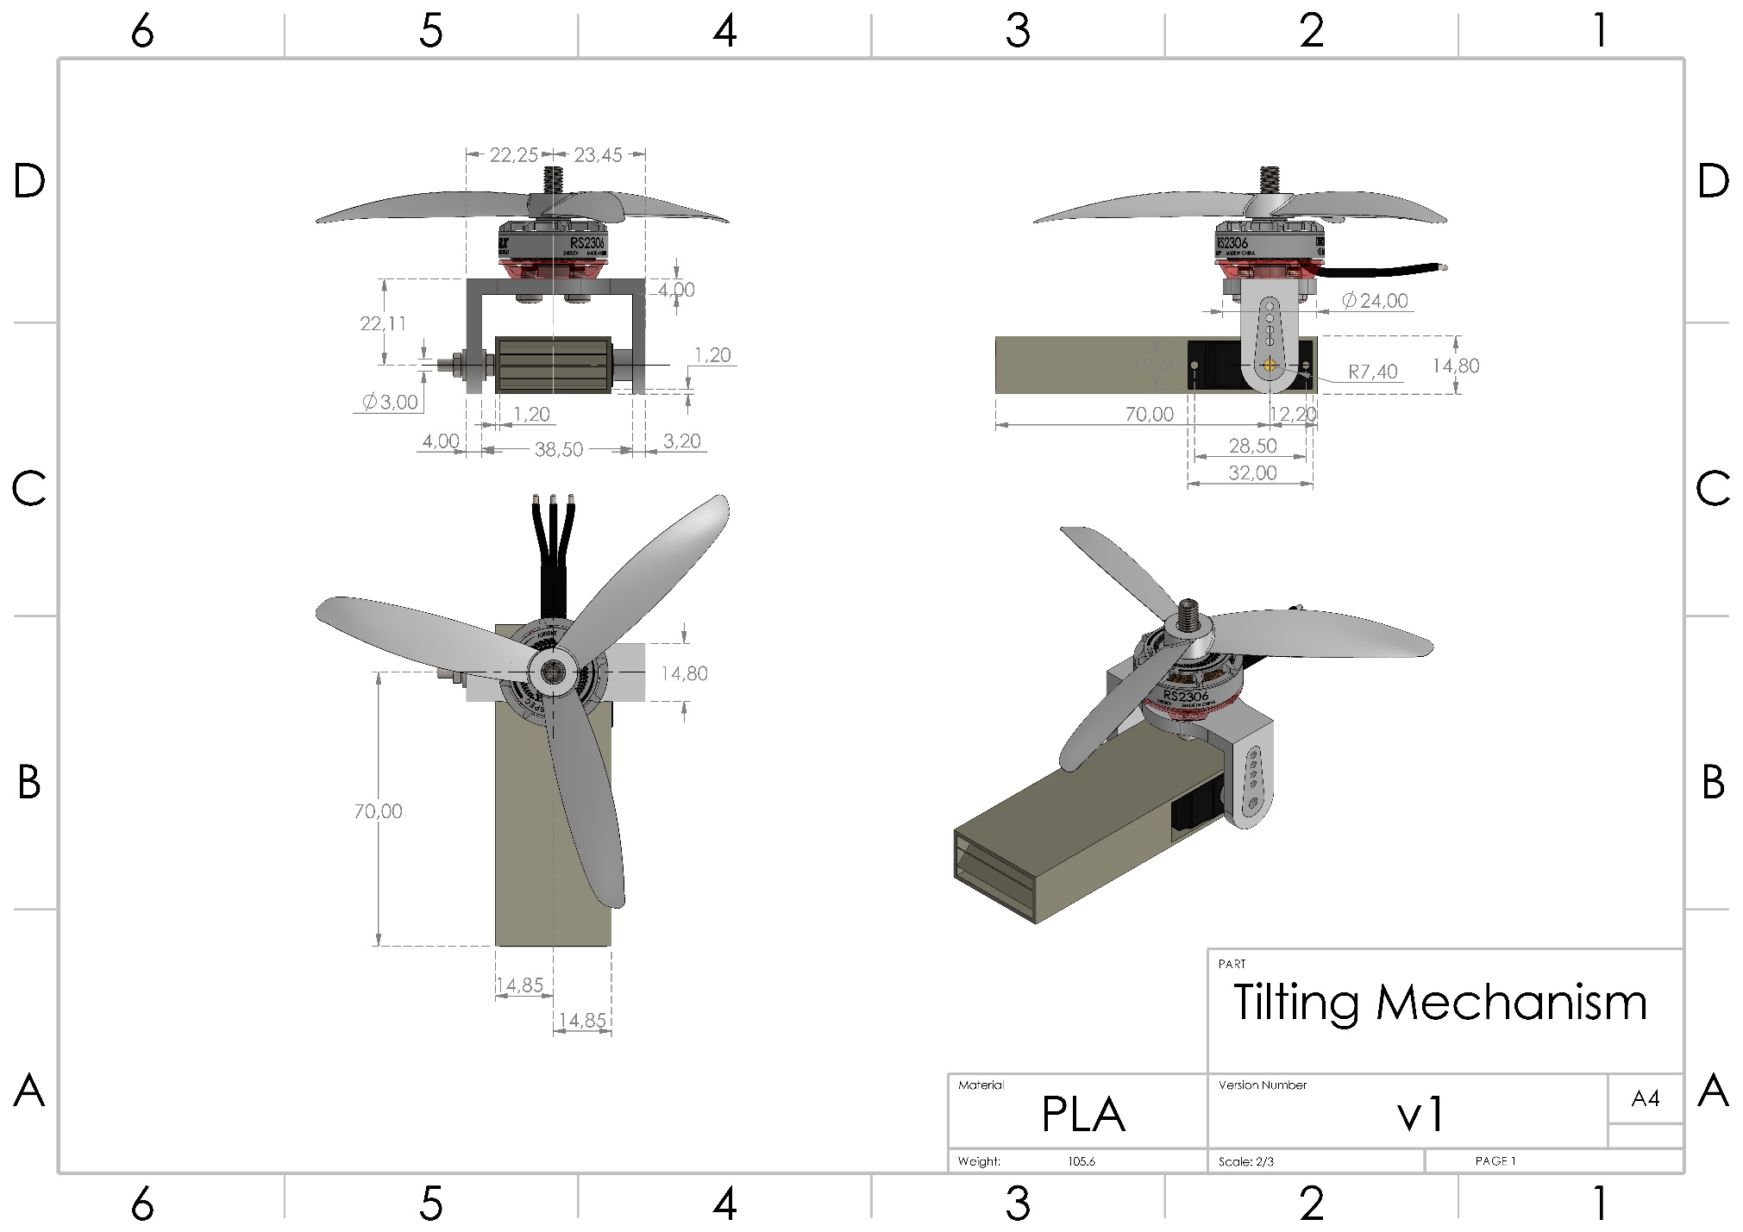

# *Appendix F Technical Drawing of the Rear Motor Mount.*

